Monday Maths Resources
Fluency Reasoning
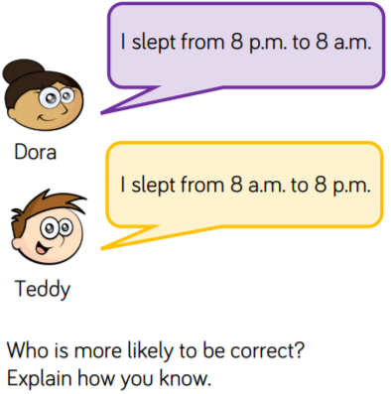
Complete this table, filling in the missing times.
24 Hour time | 12 Hour time
03:15
 | 4:00 pm
 | 7:30 am
18:45
14:30
 | 5:30 am
 | 10:45 pm
17:30
09:15
 | 6:30 am
22:30

Problem Solving
In each pair, highlight/underline/tick the time which coms earliest in the day. The first one is done for you.
3:15 pm | 11:30
04:15 | 4:30 am
13:15 | 1:00 pm
8:30 pm | 09:15
11:30 am | 23:30
14:30 | 2:15 pm
12:15 am | 00:20

