Australian Animals
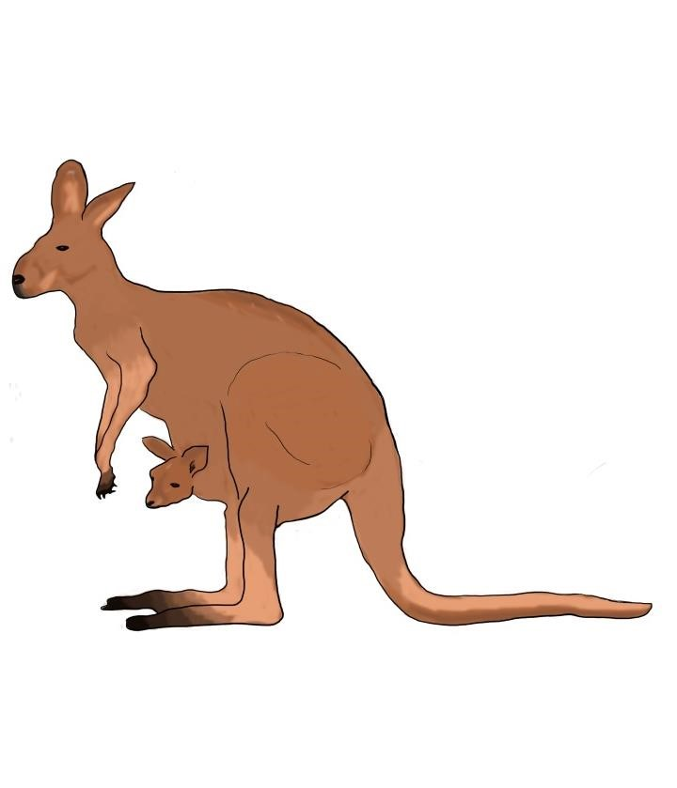
Australia is a country in the south of the Pacific Ocean. Australia is known for its wildlife and has many native animals living there. In fact, most of the animals that live in Australia are not found anywhere else in the world.

Kangaroos
The kangaroo is probably the most well known Australian animal. Kangaroos are a type of animal called marsupials which means that they have a pouch. They use the pouch to carry their babies. A baby kangaroo is called a Joey. Kangaroos
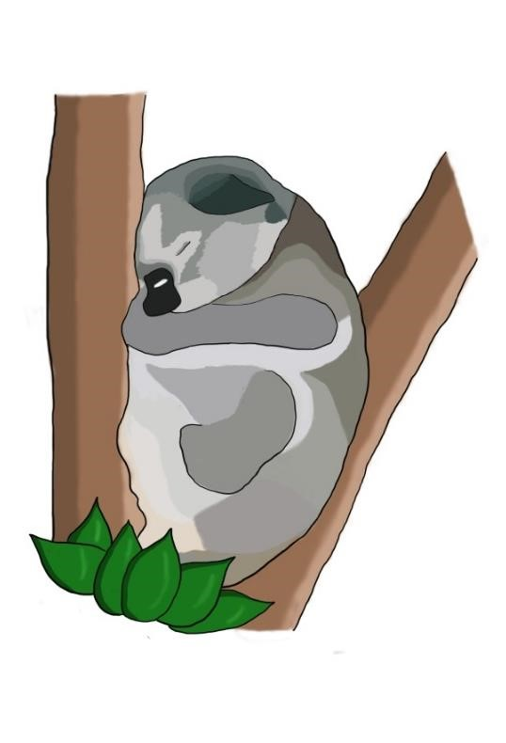
have large, strong legs which means they can jump very high. Their powerful legs can also be quite a dangerous weapon. Kangaroos are herbivores and mainly eat different types of grasses.

Koalas
Koalas are related to kangaroos as they too have pouches. They are often known as koala bears because they look cuddly but they are actually not bears at all! Most of a koala’s day is spent sleeping in trees. Normally, they come out at sunset to eat and move around. They eat leaves from gum trees. Even though they live in a hot climate, they don’t drink because they get enough water from the leaves they eat.

Did you know that
there are more
kangaroos than humans
in Australia?

Duck Billed Platypus
The duck billed platypus is so called because its snout looks like a duck’s bill. They are found in Eastern
Australia in rivers and lakes. They are a special type of mammal because they lay eggs. Having webbed feet makes them very good swimmers.
They also like to dig burrows in the riverbanks. The diet of a platypus is mainly made up of fish and insects.

Emus
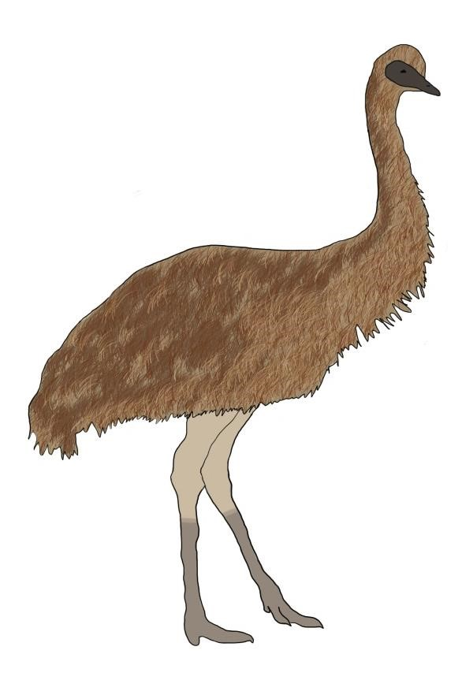
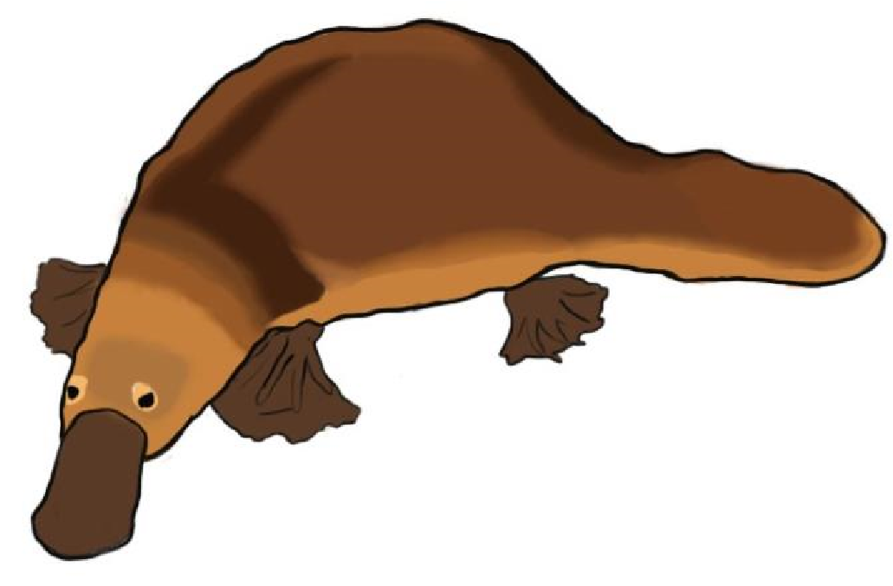
The emu is Australia’s largest bird and can stand up to two metres tall. They are flightless birds with long, thin necks and long, powerful legs. The emu is a member of the same bird family as the ostrich. They can be found all over Australia from the snowy mountains to the dry plains. They do, however, prefer to live in remote places. Emus make a deep, drumming sound with their throat which can be very loud. They mainly feed on plants but they will eat insects when available.
Did you know that an emu can be heard from over a hundred metres away?

Australian Animals – Follow-Up Work
What is the main purpose of this text?
_______________________________________________________________________________________
Is this is a fiction or non-fiction text?
_______________________________________________________________________________________
Why do kangaroos have pouches?
_______________________________________________________________________________________
What adjectives did the writer use to describe kangaroos’ legs?
_______________________________________________________________________________________
What feature do kangaroos and koalas share?
_______________________________________________________________________________________
How many paragraphs are there in this text?

What kind of sentences are in the orange boxes?
_______________________________________________________________________________________
Why is it surprising that koalas don’t drink?
_______________________________________________________________________________________
Where does the name ‘duck billed platypus’ come from?
_______________________________________________________________________________________
What are the subheadings for?
_______________________________________________________________________________________
What other bird is the emu related to?
_______________________________________________________________________________________
What other texts have you read like this?
____________________________________________________________________________________

