Number square challenges

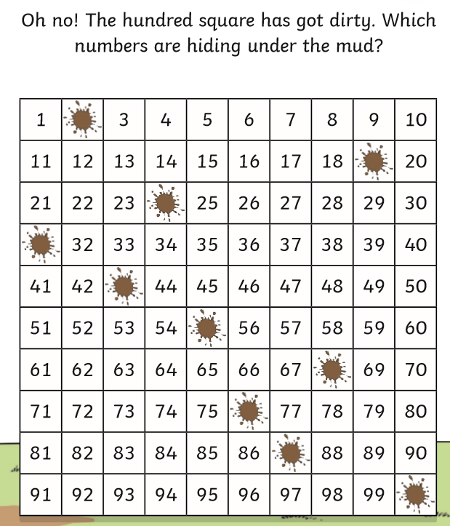

If you get children to count from 1 – 100 can they identify the numbers without using the number square, and then they can use that to check their own answers.
Challenge questions:
Is there an easy way of working out what the splat below is without having to count on from 66?
Can they work out quickly what number comes directly under 90 and why?
Can they work out quickly which number comes directly above 65 again without counting?
Answers – Looking to see if the children can identify that numbers directly below one another are ten more and therefore numbers directly above one another is 10 less. Can they see that the tens number digit but the ones digit does not?
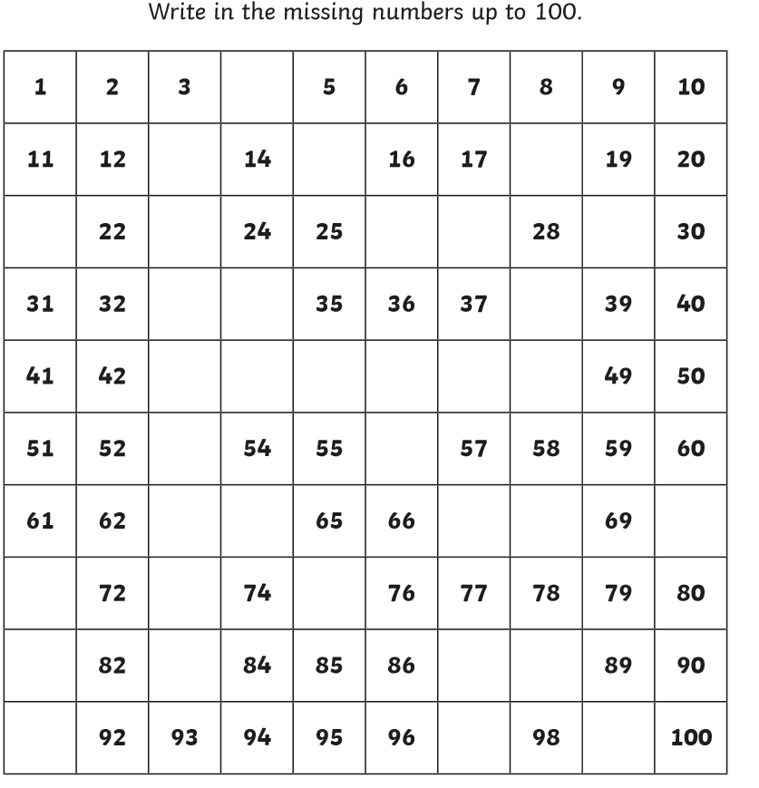

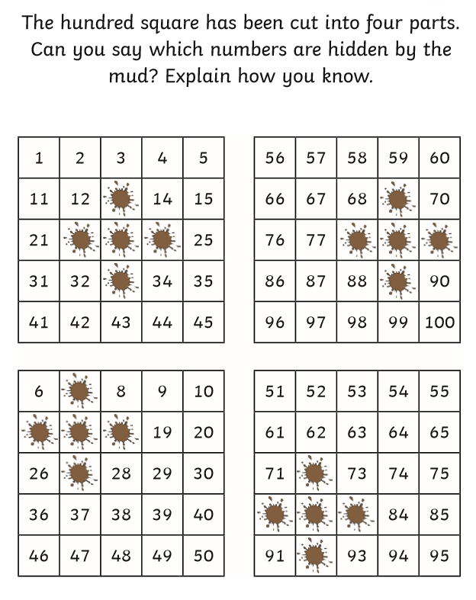
Discussion questions to ask the children when they are working it out or after (if you would like them)
Can you use numbers on the number square to work out the missing numbers rather than counting all the way from 1 each time? Get them to pick a missing number or two and explain how they worked it out. Answers:
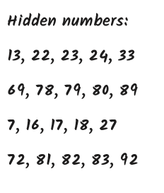
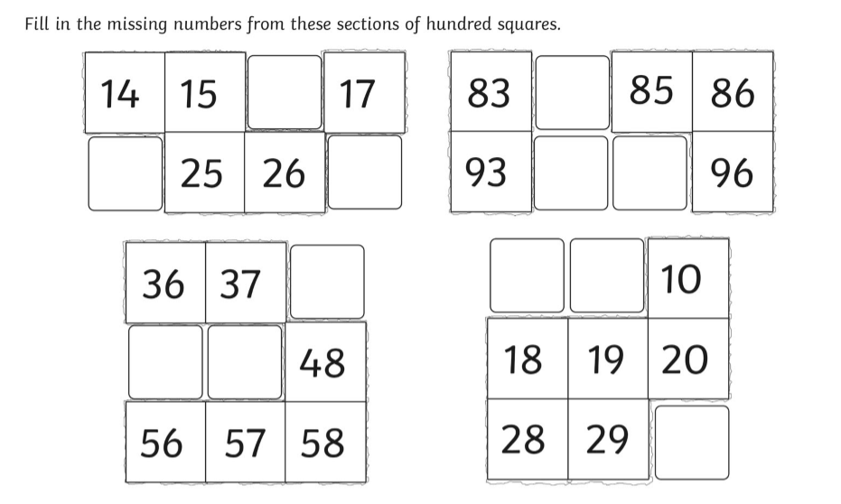
Extra missing number challenges:

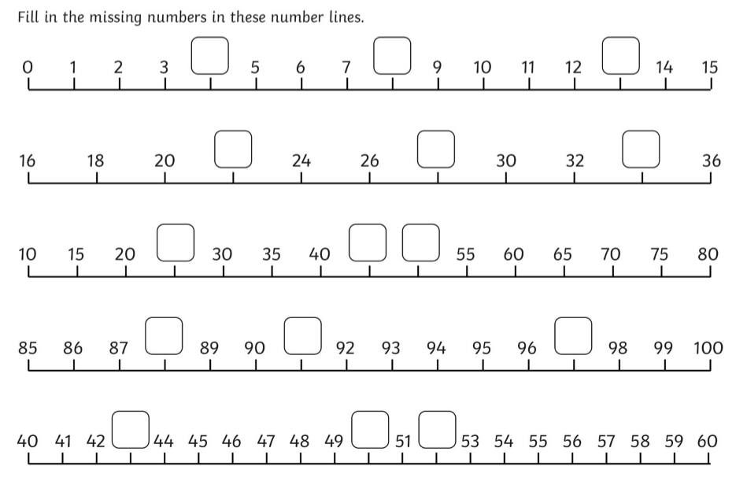

Answers for the extra missing number challenges
