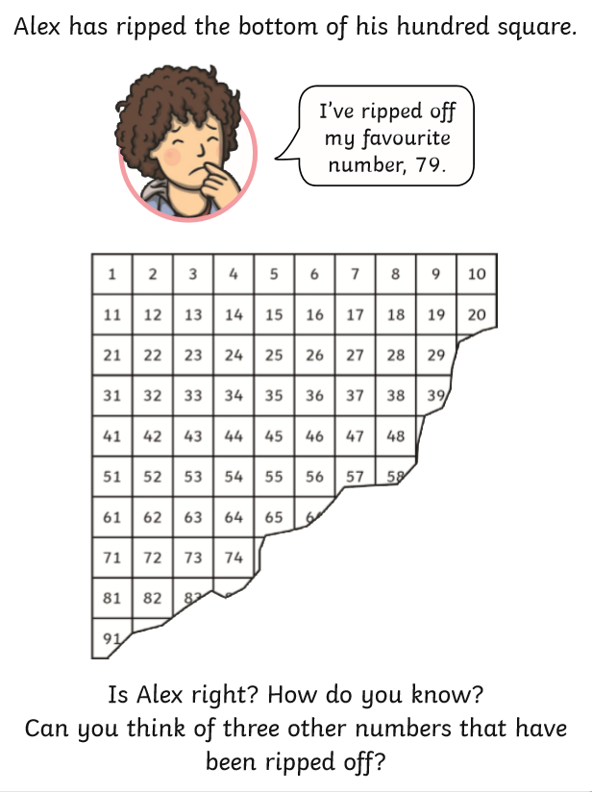
Answer:
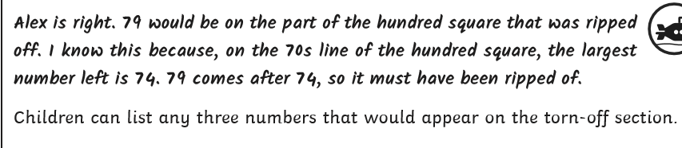

https://nrich.maths.org/5572

The link above takes you to the NRICH website where there are 4 puzzles where the children need to place that parts of the number square in the right place in order to then complete the number squares.
You can either do it interactively online following the link or you can print off the pages using this links at the bottom of the website page.

