Maths
Maths this week will be consolidating addition and subtraction to 20.
Use number squares as needed to help solve the calculations. Some of the calculations will be missing numbers and some will be one step word problems. I have put them into tasks/days.
Task 4 and 5 is a separate resource – it is a series of questions to do with a pet shop, again consolidating addition and subtraction.
Task 1
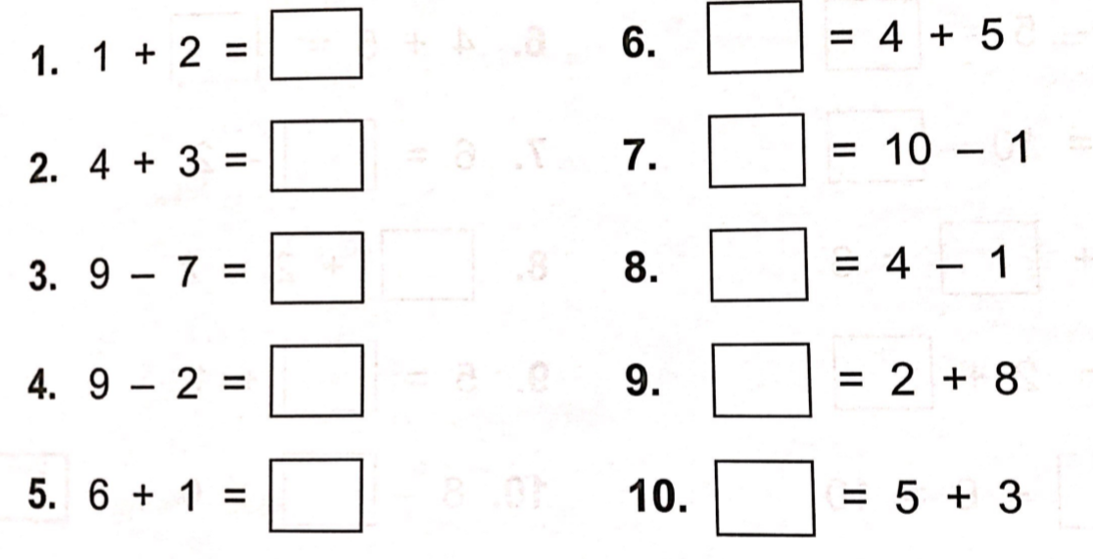

11. If you have 6 toys but then you lose 4 toys, how many are you left with?
12. Sammy the giraffe has 5 spots and Timmy the giraffe has 6 spots. How many spots do they have altogether?
13. Take away 3 pencils from 8 pencils. How many are you left with?
Answers
- 3
- 7
- 2
- 5
- 7
- 9
- 9
- 3
- 10
- 8
- 2
- 11
- 5
Task 2
We have previously done a lot of work about moving the equals sign within the calculation – getting the children to recognise it means equal to/the same as and does not always have to go at the end of a calculation.
So for example question 7 it’s saying 6 is the same as what take away 2. Or what would you take away from 2 to be left with 7?
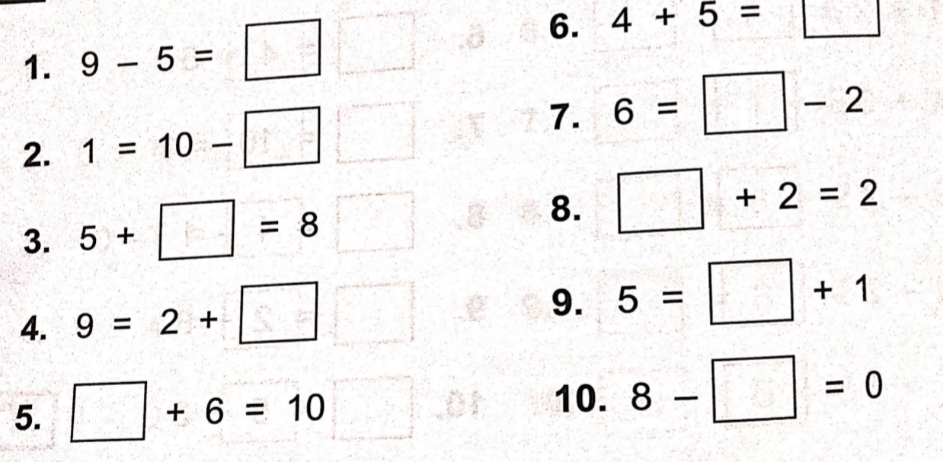
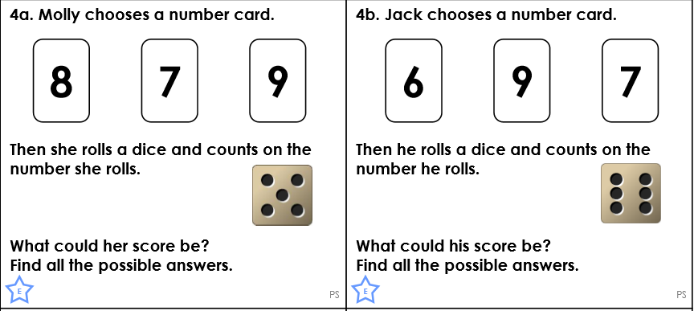
Reasoning and problem solving

Answers
- 4 9. 4
- 9 10. 8
- 3 Reasoning and problem solving:
- 7
- 4
- 9
- 8
- 0
Task 3
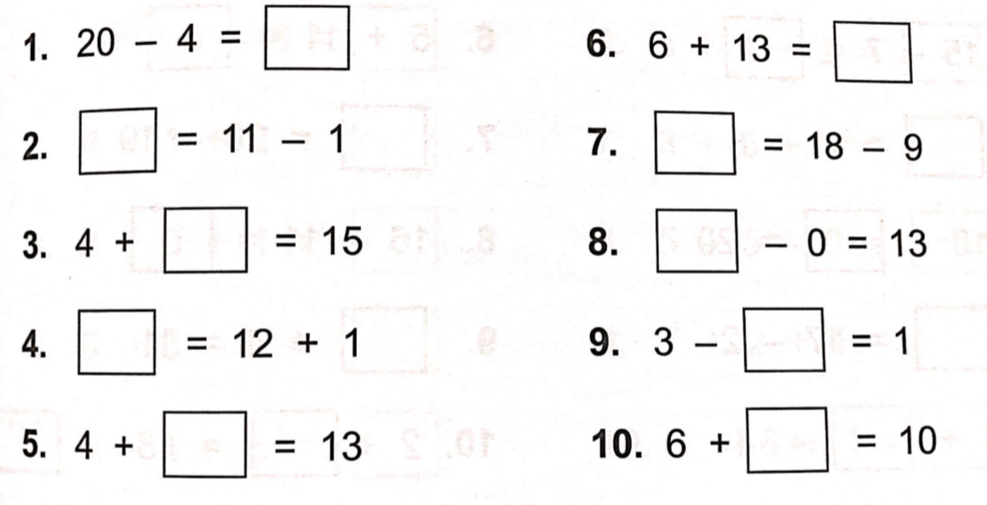
Reasoning and problem solving
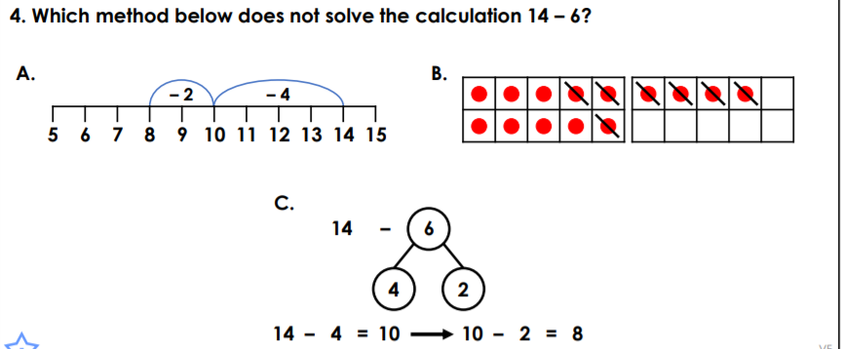

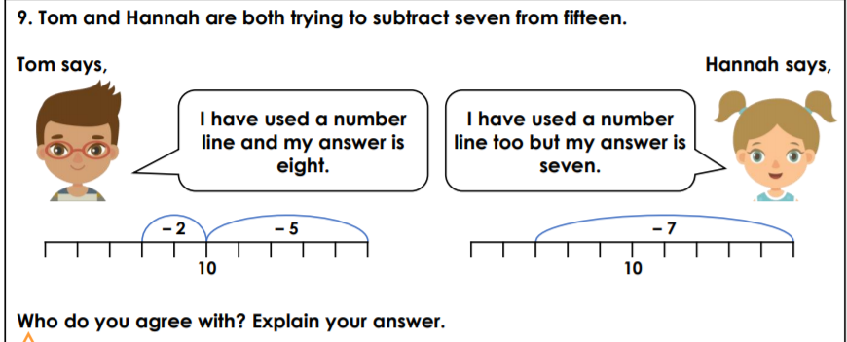
Task 3 Answers
- 16
- 10
- 11
- 13
- 9
- 19
- 9
- 13
- 2
- 4

Reasoning and problem solving
- B
- Tom is correct because he has partitioned the number into 5 and 2 to subtract 7. Hannah has not partitioned the number and has counted wrong. She has subtracted 8 so she has got the wrong answer.

