While you are at home pick 1 or 2 activities a week to complete.
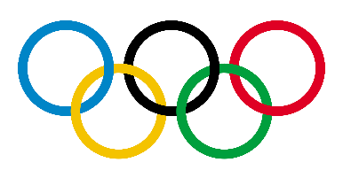  History  Create a timeline of the Olympic Games. When did it start? How many different countries has it been in? – could you place a dot on a map of the world to show all the different countries the Olympic Games have been in? | 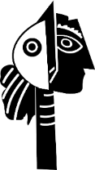  Art  Plan your very own sculpture. You will need to think about what you want to make and the effect’s you will use. We would love to see you planning which could include sketches or mock up of your design.  Can you make your sculpture? You can be really creative using items from home like playdoh, Kinex, Meccano or Lego. Perhaps you could find other materials such as items from your recycling or even wood if someone can help put it together safely. | 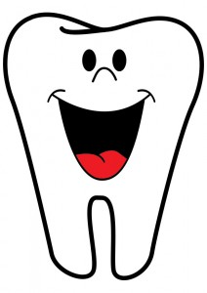  Science  We have already identified the different types of teeth that humans have.  Choose an animal of your choice. Can you produce a poster about teeth for your animal? Include facts and draw comparisons to human teeth. E.g. size of teeth, names of the different types of teeth, what the function of that tooth is etc.
Design and Technology  Plan your family’s meals, drinks and snacks for a day. You will need to make sure you think about how to ensure that you are having a having a health balanced diet.  Display what food you will eat in a fun way to show us what you have chosen to eat.  Can you identify which foods are seasonal? Are there advantages to eating seasonal local food? If so tell us what they are.  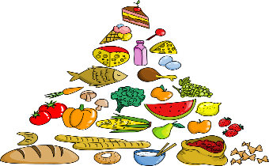  This Photo by Unknown Author is licensed under CC BY | Physical Education  Even though we are in lock down most of us are allowed out once a day to exercise.  Explain why is exercise so important for our physical and our mental health?  Design an exercise routine you can do at home. Perhaps you could do circuits such as skipping, jogging on the spot, step ups on bottom step of your stairs… | Geography  Draw a map with a key.  The more accurate the better.  Perhaps you could do a map of your garden or of the route you take for your daily exercise.  If you can’t get out at the moment can you draw a treasure map from your imagination? If you play a game like Minecraft can you create a map from that?  