Summer Suitcases

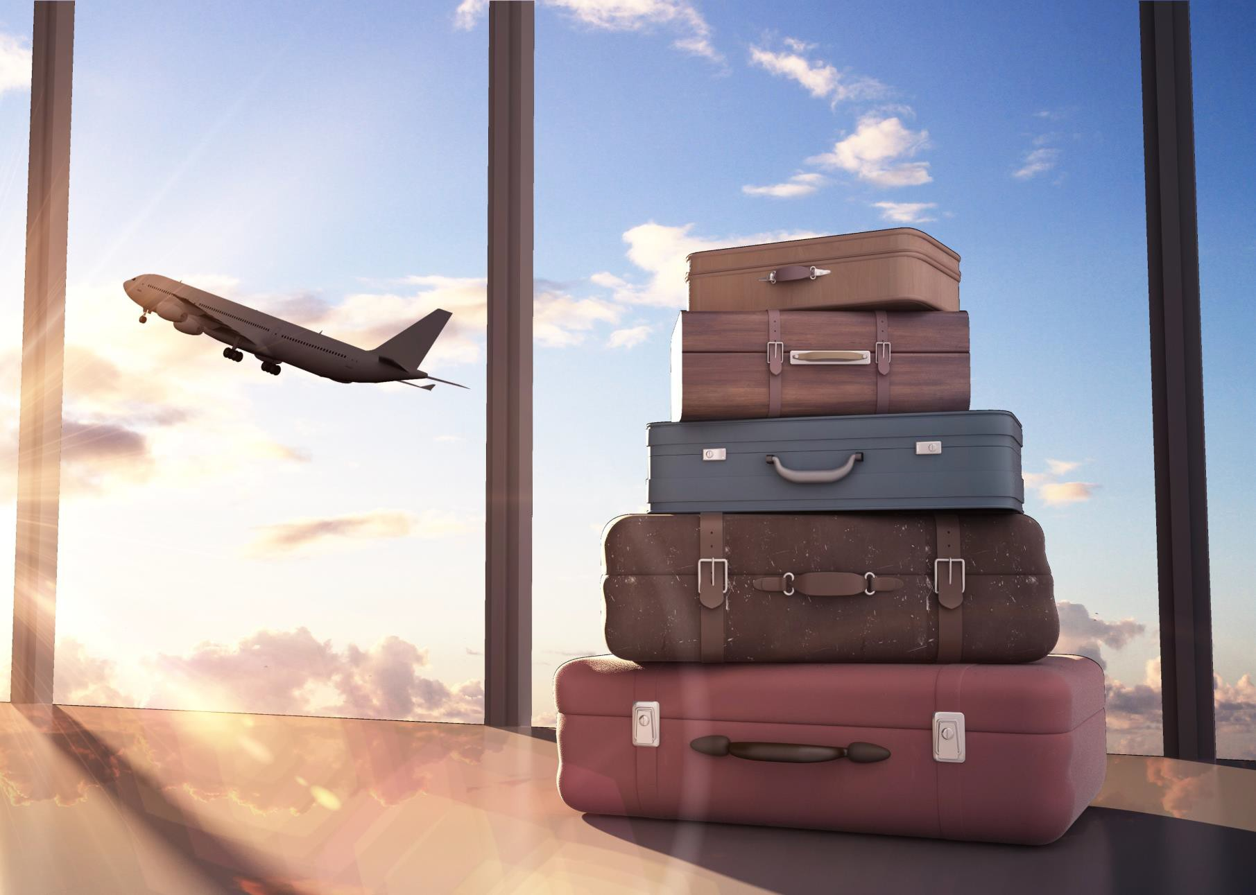

Summer Suitcases – Follow-Up Work

- What do the suitcases represent? Explain your reasons.
- Who might be travelling? Where might they be going?

- If this were an image on an advert, what might the advert be for?
- The weather in the image is of a sunny day with some clouds. Does this give a positive or negative feeling? Explain your reasoning.

- What is the main focus of the picture? How do you know?
- Where is the image taken?

- What feelings might the picture make you feel? Give three examples.
- Imagine there is a person in the image. What would you like to ask them?

- The suitcases look different to suitcases used now. What might this suggest?
- Why has the illustrator chosen to have five suitcases piled up? What might this suggest?

- Explain a time when you travelled somewhere. How was it the same or different as the picture?
- What else might you add to the picture to give it more meaning?

Summer Suitcases – Vocab 1 Write the definitions for each of these words.
departure
arrival
transportation
destination
exchange
currency
foreign
recreation
souvenir
expedition
excursion
tourism
voyage
embark

Summer Suitcases – Vocab 2
Select the correct spelling to match the meaning.

activity that is done for enjoyment
- recraetion  - recreation | - re-creation  - re-craetion

a short journey or trip often for enjoyment
- excursion  - excurrision | - excurson  - excurrsion

a journey undertaken by a group of people particularly to explore an area
- expediton  - ecspedition | - expidition  - expedition

Find ten words using just the letters in the words below.

departure

tourism

Summer Suitcases – SPAG

The word holiday can be used as a verb or a noun.

- Write one sentence using the word holiday as a noun.

Remember to punctuate your answer correctly.

- Write one sentence using the word holiday as a verb.

Remember to punctuate your answer correctly.

Rewrite the sentence below, adding a relative clause. Remember to use the correct punctuation.

The aeroplane was delayed.

Which conjunction is best to complete the sentence below? Tick one.

The queue to board the aeroplane was long the staff were processing boarding passes as quickly as they could.

in addition
since
however
and

Summer Suitcases answers

- What do the suitcases represent? Explain your reasons? Holidays and travel because people carry suitcases when they travel. There is more than one suitcase suggesting that it may be a group of people travelling. The suitcases vary in size suggesting that there are adults and children travelling.

- Who might be travelling? Where might they be going? Various answers. Students may suggest a family is travelling as there are multiple suitcases. Various answers for destinations.

- If this were an image on an advert, what might the advert be for? Holidays, travel,
suitcases, an airport.

- The weather in the image is of a sunny day with some clouds. Does this give a positive or negative feeling? Explain your reasoning. Positive as sunny/warm weather makes people feel happy.

- What is the main focus of the picture? How do you know? The suitcases as they are in the
foreground and near to the middle of the image.

- Where is the image taken? In an airport, or in a place overlooking an airport.

- What feelings might the picture make you feel? Give three examples. Happy, excited, relaxed. Accept other suitable answers with justification.

- Imagine there is a person in the image. What would you like to ask them? Personal response. Students may want to ask about the holiday they have either been on or are going on.

- The suitcases look different to suitcases used now. What might this suggest? That the image was taken in the past, that the suitcases belong to someone who has had them a long time, e.g. an older person.

- Why has the illustrator chosen to have five suitcases piled up? What might this suggest? Might suggest a group/family of people, differing in size like their suitcases. They are piled up waiting and ready to go somewhere.

- Explain a time when you travelled somewhere. How was it the same or different as the picture? Personal response, students must justify why their travel was the same as or different to the image.

- What else might you add to the picture to give it more meaning? Various responses. Students may suggest; people, tickets, passports, brochures.

Summer Suitcases – Vocab 1 Write the definitions for each of these words.
departure | the action of leaving a place
arrival | entry, appearance at a place
transportation | movement of things from one place to another
destination | the place where something or someone is going to
exchange | changing of money to the current currency to use in a different country
currency | a system of money used in a country
foreign | showing characteristics of a county, language or culture that is different to your own
recreation | activity done for the purpose of enjoyment when not working
souvenir | a thing that is bought or kept to remind you of a place, person or event
expedition | a journey undertaken by a group of people, particularly to explore an area
excursion | a short journey or trip often for enjoyment
tourism | The industry of providing services for visitors to particular desitination
voyage | a long journey often by sea or in space
embark | go onboard a ship or aeroplane

Summer Suitcases – Vocab 2
Select the correct spelling to match the meaning.

activity that is done for enjoyment
- recraetion  - recreation | - re-creation  - re-craetion

a short journey or trip often for enjoyment
- excursion  - excurrision | - excurson  - excurrsion

a journey undertaken by a group of people particularly to explore an area
- expediton  - ecspedition | - expidition  - expedition

Find ten words using just the letters in the words below.

departure
adept dear dearer deep deer depart drape ear era erupt pad pared pat pea peat peer put rare read reaped rear red repeat rude rut tap tape taped tar trade trader tree

Accept other answers.
tourism
most must omit ours out rim riot rots rust ruts sir sit so sort sour stir storm sum tors tour tours trims us

Accept other answers.

Summer Suitcases – SPAG

The word holiday can be used as a verb or a noun.

- Write one sentence using the word holiday as a noun.

Remember to punctuate your answer correctly.
Accept multiple answers. e.g. I spent most of the summer holiday in the forest.
- Write one sentence using the word holiday as a verb.

Remember to punctuate your answer correctly.
Accept multiple answers. e.g. He is planning to holiday in Spain next year.

Rewrite the sentence below, adding a relative clause. Remember to use the correct punctuation.

The aeroplane was delayed.
The aeroplane, which was arriving from Portugal, was delayed.

Which conjunction is best to complete the sentence below? Tick one.

The queue to board the aeroplane was long the staff were processing boarding passes as quickly as they could.
in addition
since
however | ✓
and

