Animal Town!
This week I have used Pobble 365 to create a series of writing tasks around the illustration above – ‘Animal Town’. The list of writing opportunities is not exhaustive – maybe you have your own ideas for a writing task you could undertake? Don’t forget to celebrate your learning with me – email it across and I promise I will reply!
Imagine you are a visitor in Animal Town. Try to describe your experience. | What animal would you most like to meet in Animal Town?  Produce a leaflet or fact file about this animal. | Describe what the scene would look like in the supermarket! Make it as amusing and chaotic as you like! | Story Starter:  Most visitors are a little shocked (to put it mildly) when they arrive at Animal Town. Despite the fact that the name of the town gives a slight indication to passers-by that the inhabitants of the town are ‘not normal’, it’s as if people don’t believe things until the see them with their own eyes!  Once you get used to being in Animal Town – or so they say – seeing an orangutan behind a desk in a sheriff’s office and upholding the law to an impeccably high standard becomes relatively ‘normal’…
Sentence Challenge:  Can you use verbs and adverbs to describe what each of the animals in the picture are doing? E.g.  The zebra meanders lethargically across the road.  Nonchalantly, the orangutan lounges on the bench.  Can you think of your own? Aim for at least 5.  You could experiment by using adverbs in different places in your sentences. | Design and make a set of top trump cards based on animals.  Maybe they could all be animals from the same habitat?  Think carefully about what your top trumps criteria would be. | Design a poster to show how you care for your pet.  If you don’t have one, can you brainstorm and research what you will need and how to take care of a pet you would like? | For all these tasks, please try to think about and include:  - Write in paragraphs, grouping related material together.  - Expanded noun phrases with prepositional language  - Fronted adverbials  - Ensure standard English forms for verb inflections, e.g. we were instead of we was, I did instead of I done.  - Proof read your work for spelling and punctuation errors  - Subordinate clauses
Look very carefully at the Year 3 / 4 Common Exception Word List.  Identify 8 spellings that you are still working on and focus on these this week. Think about some of the strategies we have learnt in class. How creative can you be in how you practise them? | 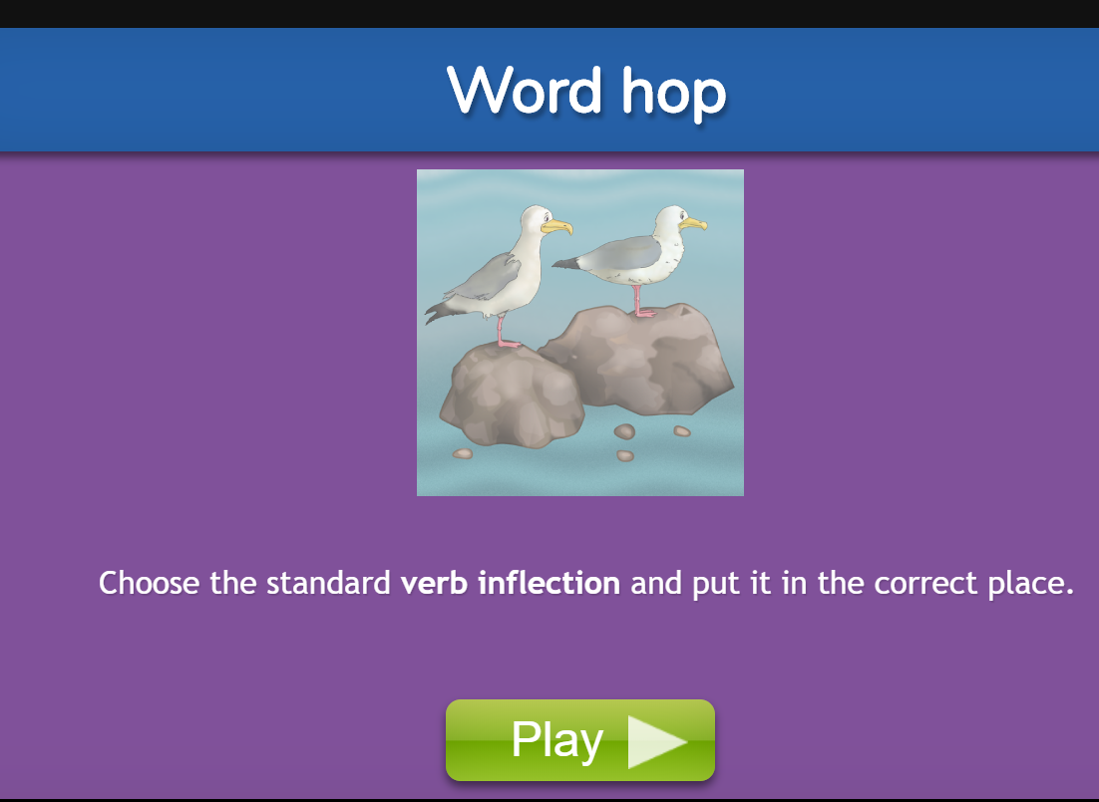 |  | Spelling rule  Recap:  The sound spelt ‘y’ elsewhere than at the ends of words.  myth  gym  Egypt  pyramid  mystery  crystal  symbol  syrup  cygnet  lyric

