2020 revision and consolidation: Roman numerals and Rounding
Q1.
Here is a number written in Roman numerals.
CXV
Write the number in figures.
1 mark

Q2.
Complete the table.

 | Number | Roman Numerals
 | LX | 60
 | LXXVI
 | XCIII

2 marks

Q3.
Look at these numbers written in Roman numerals.
MCMVII MMCD MDCCXLIII MMDX
Circle the largest number.
What is the value of the smallest number?
2 marks

Q4.
Here are four digit cards.
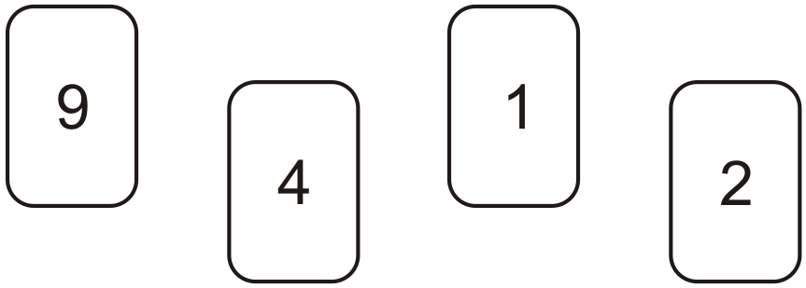
Use each digit card once to make the decimal number nearest to 20
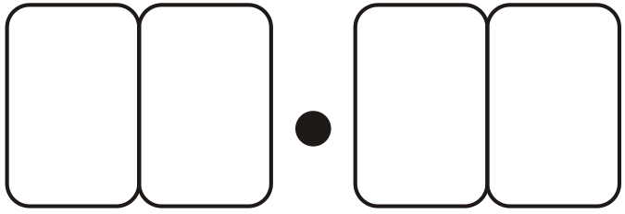
1 mark

Q5.
Here are three supermarket bills.

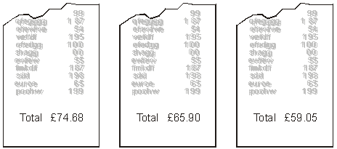
Tom rounds each bill to the nearest £10 and then adds them up.
What is the total amount that Tom gets?
1 mark
Mary adds up the three bills exactly.
What is the total difference between her total and Tom’s total?

2 marks

Q6.
Look at these numbers written in Roman numerals.
One is not written correctly.
Put a cross (✘) on it.
MMCM MCMM MMMC MMCC MCCC
1 mark

Q7.
The difference between two numbers is 2
When each number is rounded to the nearest hundred, the difference between them is 100
Write what the two numbers could be.
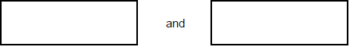
1 mark

Q8.
Round 124,531

to the nearest 10,000
to the nearest 1,000
to the nearest 100

2 marks

Q9.
Chen chooses a prime number.
He multiplies it by 10 and then rounds it to the nearest hundred.
His answer is 400.

Write all the possible prime numbers Chen could have chosen.

__________________________________
2 marks

Q10.
Runa and Jon each start with the same number.

Runa rounds the number to the nearest hundred.
Jon rounds the number to the nearest ten.

Runa’s answer is double Jon’s answer.
Explain how this can be.

1 mark

M1.115
Commentary: The 2014 national curriculum specifies that pupils should read Roman numerals to 100 (4N3a) and then to 1000 (5N3a).
[1]

M2.
Number | Roman Numerals
LX | 60
LXXVI | 76 | 1
XCIII | 93 | 1

[2]

M3.MMDX indicated
Do not accept MDCCXLIII
1
1743
1
[2]

M4. 19.42
[1]

M5. (a) £200
1

(b) Award TWO marks for the correct answer of 37p OR £0.37
OR
for finding the correct difference between £199.63 and the answer given for 13a
Answer to (a) must be a multiple of £10 for the award of TWO follow-through marks.
If the answer is incorrect, award ONE mark for evidence of appropriate method, eg
74.68 + 65.90 + 59.05 = 199.63
200 – 199.63
OR
for evidence of an appropriate method to find the correct difference between £199.63 and the answer given for (a).
Answer need not be obtained for the award of ONE mark.
Accept for ONE mark £37p OR 0.37p OR £37 as evidence of appropriate method.
Up to 2
[3]

M6.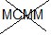
Accept other clear indication
[1]

M7. Two numbers with a difference of 2, in the range 48 inclusive to 52 exclusive eg:
■ 48 AND 50
OR
■ 51.9 AND 49.9
OR
any pair of numbers that differ from those above by a multiple of 100 and have a difference of 2, eg:
■ 149 AND 151
OR
■ 648 AND 650
Numbers can be given in either order.
U1
[1]

M8.Award TWO marks for all three numbers correctly rounded:
120,000
125,000
124,500
If the answer is incorrect, award ONE mark for any two numbers correctly rounded.
Up to 2
[2]

M9.Gives only the three correct prime numbers in any order, ie:
• 37, 41, 43
2

or
Gives at least two correct prime numbers and
not more than one incorrect number, eg:
• 37, 39, 41, 43
• 39, 41, 43
• 41, 43
1
[2]

M10. Gives a correct explanation with a number x such that 50 ≤ x x as an example, eg:
• 53 to the nearest hundred is 100, and to the nearest ten is 50 and 2 × 50 = 100
• If it’s 50 or more but less than 55 it will round to 100 (nearest hundred) and 50 (nearest ten) and 100 is double 50
• 0 is 0 to the nearest 100 and 0 to the nearest 10 and twice 0 is 0
Accept minimally acceptable explanation, eg:
• 51 rounds to 50 and 100
• 54 50 and 54 100
• 50 rounds to 100
• 0 rounds to 0

Do not accept incomplete or incorrect explanation, eg:
• They used 51
• 50 × 2 = 100
• They could use between 50 and 55, which round to 100
U1
[1]

