Statistics 2020 – finding the mean
Some of you will already know how to find the mean of a set of data.

The mean is one way of finding an average. (You can also find the median or the range, but that is something for secondary school)
To find the mean you add up all the numbers then divide your answer by how ever many numbers you had in the first place.
Example: the mean of 4 5 6 7 and 8 is 4+5+6+7+8 which is 30, then divide 30 by 5 (how many numbers you had in the first place) and the answer is 6. Therefore, the mean is 6
Your turn
Fluency
1) Calculate the mean of these sets of numbers:
a) 3, 6, 8, 2, 4, 13 (6)
b) 7, 13, 16, 9, 10 (11)

2) Hassan is his school’s cricket team’s top batsman. His scores over the year are:

134, 60, 17, 63, 38, 84, 10
Calculate the mean number of runs Hassan scored. (58)
3) Four children have taken two tests, one English and one Maths.

Calculate the mean:
a) Maths score (64.5)
b) English score (63)
c) score overall (63.75)
d) score for each child over both tests
Ali 63
Sid 57
Pam 61.5
John 73.5

4) Seven children measured their heights.

Children | Height (cm)
Stefan | 144
Lara | 136
Olivia | 142
Chen | 143
Maria | 152
Dev | 148
Sarah | 150

What is the mean height of the children? 145

Reasoning

- Three apples have a mean (average) mass of 100 grams.
The largest apple is removed.
The mean mass of the remaining two apples is 70 grams.
What is the mass of the largest apple?

2) The arrow below points to the mean of the three numbers shown by crosses.

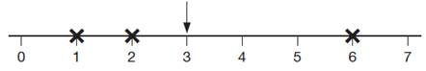

(a) Draw an arrow that points to the mean of the three numbers shown below.

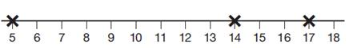

(b) The arrow below points to the mean of three numbers.
One of the numbers is missing.
Draw a cross to show the position of the missing number.

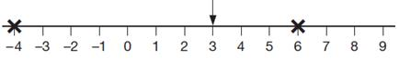

- Six children have taken a mental maths test. The mean score was 15 out of 20

Find the missing score in the list of scores below
- 16 17 13 12 ??

- Jasmine says that the mean average is always a whole number. Do you agree? Explain your reasoning.

Problem Solving

- Make up a set of five numbers which have a mean of 3.6 Can you find more than one combination of five numbers?

- Megan goes on a walking holiday for five days.
The table shows how far she walked on the first four days.

 | Monday | Tuesday | Wednesday | Thursday
 | 14 km | 23 km | 13 km | 13 km

Megan says,
‘My average for the first four days is more than 15 km.’
Explain why Megan is correct.

Friday is her last day. She wants to increase her average to 17 km. How many kilometres must she walk on Friday?

