2020 revision of learning you will have done in previous years

Other types of charts
Q1.
Amy did a survey of what time people get up on a Sunday morning.
This table shows her results for 150 people.

 | Time | number of people
 | before 7 am | 13
 | 7:00 am to 7:59 am | 28
 | 8:00 am to 8:59 am | 59
 | 9:00 am to 9:59 am | 36
 | 10 am and after | 14

Look at the table.
How many people get up at 8 am or later?
1 mark

Amy says,
'Two-thirds of the 150 people in the survey get up before 9 am.'
Amy is correct.
Explain how you know.

Q2.
Here is a table of temperatures at dawn on the same day.

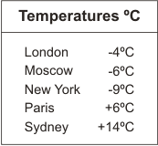
What is the difference in temperature between London and Paris?

At noon the temperature in New York has risen by 5°C.
What is the temperature in New York at noon?

Q3.
Here is a Venn diagram for sorting numbers.
Write each number in its correct place on the diagram.
10 11 12 13

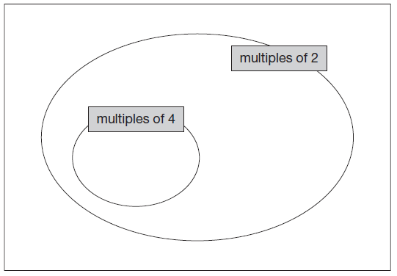
Q4

The table shows the cost of coach tickets to different cities.

 |  |  | Hull | York | Leeds
 | Adult | single | £12.50 | £15.60 | £10.25
 |  | return | £23.75 | £28.50 | £19.30
 | Child | single | £8.50 | £10.80 | £8.25
 |  | return | £14.90 | £17.90 | £14.75

What is the total cost for a return journey to York for one adult and two children?

How much more does it cost for two adults to make a single journey to Hull
than to Leeds?

Q5.
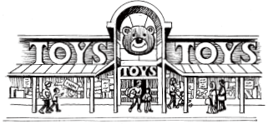
This chart shows the amount of money spent in a toy shop in three months.

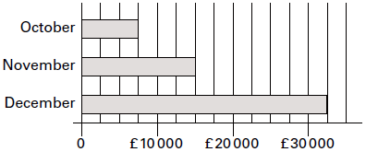

How much more money was spent in the shop in December than in November?
1 mark
Stephan says,
'In November there was a 100% increase on the money spent in October'
Is he correct?
Circle Yes or No. Yes / No
Explain how you can tell from the chart.

Q6.
People in a village were asked if they shop
in the village, or in the town, or in both.
The bar chart shows the results.

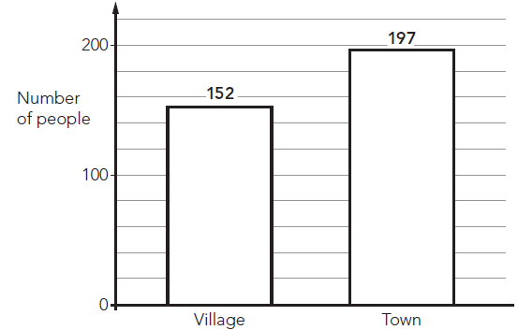

Altogether 246 people took part in the survey.
How many people shop in both the village and the town?

Q7.
Here is information about pupils in a class.
• The total number of pupils is 30
• 26 of the pupils do not wear glasses.
• A quarter of the pupils who do wear glasses are boys.
• There are 2 more boys than girls.
Use the information to fill in the missing numbers in the table below.

 |  | Number who do  wear glasses | Number who do not  wear glasses | Total
Number
of boys
Number
of girls
 | Total |  |  | 30

Q8.
This table shows the number of things to eat in five children’s lunch boxes.

 |  | sandwiches | apples | bananas | fruit bars
 | Lisa | 1 | 2 | 0 | 2
 | Jack | 2 | 0 | 2 | 1
 | Kemi | 1 | 1 | 0 | 2
 | Nik | 1 | 2 | 1 | 0
 | Ben | 2 | 1 | 2 | 1
Here is a graph of the information for four of the children.
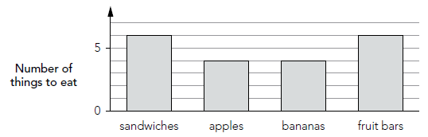
Which child’s information is missing from the graph? Explain how you know.

You may not have seen the following two types of charts before, but give them a go
Q9.
Alfie asks some boys and girls about their favourite hobby.
He shows the results on a graph.

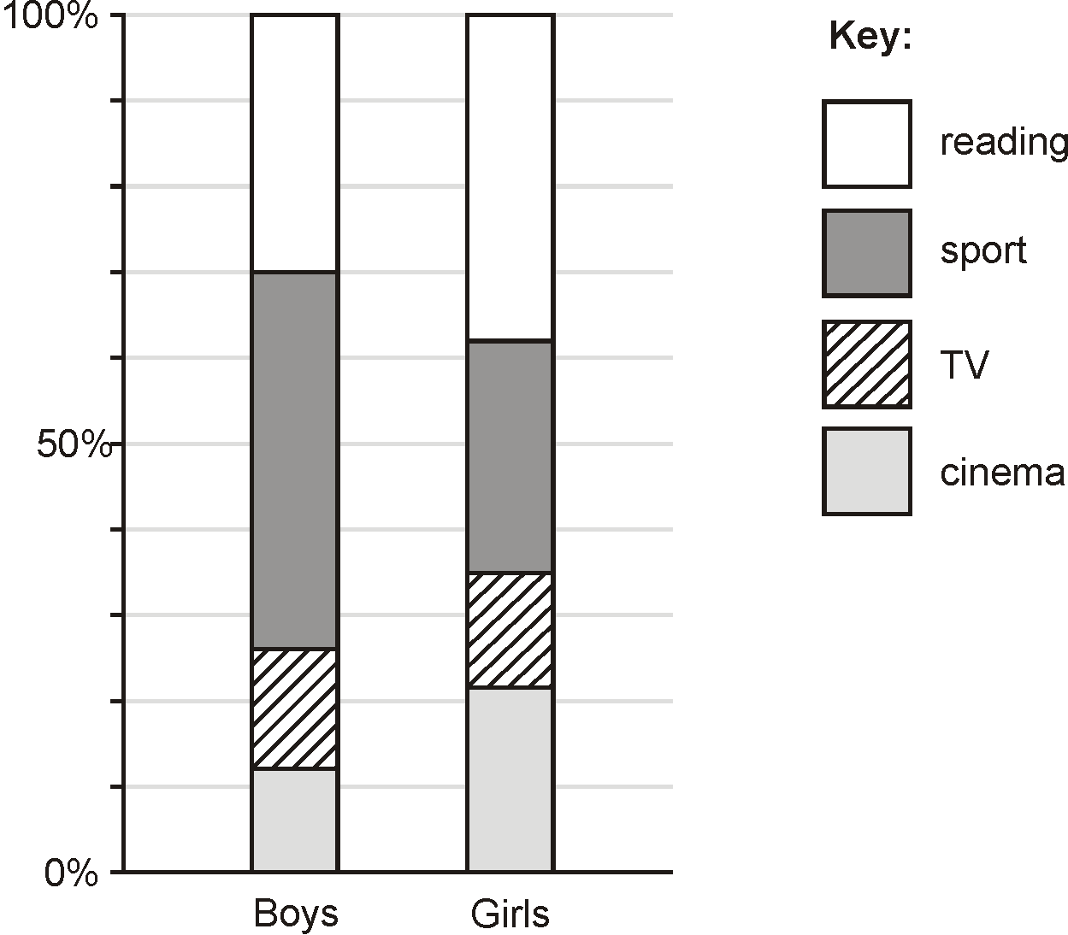
The graph shows that 44% of boys chose sport.
Estimate the percentage of girls who chose sport.

120 boys chose reading.
Estimate the number of boys who chose cinema.

Q10.
Here are three scatter graphs showing the heights of people and the cost of clothes.

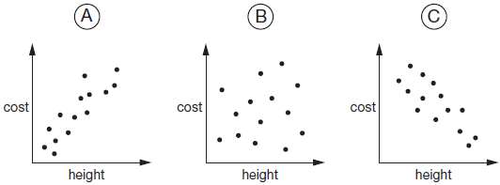
Chen says,
‘The taller you are, the more your clothes cost.’

Megan says,
‘The shorter you are, the more your clothes cost.’
Alfie says,
‘There is no relationship between your height and what
your clothes cost.’
Write the letter of each scatter graph that shows what each person says.

Chen____________ Megan ____________ Alfie ____________
1 mark

M1. (a) 109
1

(b) An explanation that recognises that 100 people get up before 9am
which is two-thirds of the total (150).
■ ‘13 + 28 + 59 = 100 which is two-thirds of the total’
■ ‘ of 150 = 50 and 2 × 50 = 100’
■ ‘ of 150 is 100’

■ ‘36 + 14 = 50 which is one-third after 9am’
Do not accept vague or incomplete explanations, eg:
■ ‘One-third are 9 o’clock or later’
■ ‘100 got up at 9am’
■ ‘Twice as many got up before 9am.’
■ ‘13 + 28 + 59 = 100’
U1
[2]

M2. (a) 10
Accept +10 OR –10
Do not accept an incomplete calculation, eg: 4 + 6
1

(b) –4
Accept ‘negative 4’ OR ‘minus 4’ OR ‘4 below’.
Do not accept ‘4–’.
1
[2]

M3. Award TWO marks for all four numbers correctly placed as shown:
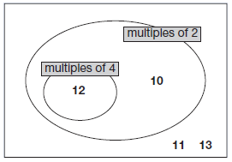
If the answer is incorrect, award ONE mark for three numbers correctly placed.
Accept alternative unambiguous indications, eg lines drawn from the numbers to the appropriate regions of the diagram.
Do not accept numbers written in more than one region
Up to 2
[2]

M4. (a) £64.30
Accept £64.30p OR £64 30
Do not accept £6430 OR £6430p OR £64.3
1

(b) £4.50
Accept £4.50p OR £4 50
Do not accept £450 OR £450p OR £4.5
If the final ‘0’ is missing from both answers, ie answers given are £64.3 and £4.5 respectively, award ONE mark only in (b).
1
[2]

M5. (a) £17 500
Accept 17500 with or without commas or spaces.
1
(b) An explanation which recognises
that November sales were double October, eg
• ‘October was 7500 and November was 7500 more which is 100%’;
• ‘November is twice October, which is 200%’.
No mark is awarded for circling ‘Yes’ alone.
Do not accept vague or arbitrary answers, eg
• ‘November is more than October’;
• ‘Because November is £15000’.
If ‘No’ is circled but a correct unambiguous explanation is given then award the mark.
1
[2]

M6. 103
2
or
Shows a complete correct method with not more than one computational error, eg:
• 152 + 197 = 339 (error) 339 – 246 = 93
• 349 – 246 = 97 (error)
• 152 + 197 = 349 349 – 246
1
[2]

M7. Completes all 8 entries of the table correctly, ie

 | ... do wear  glasses | ... do not  wear glasses | Total
... boys | 1 | 15 | 16
... girls | 3 | 11 | 14
Total | 4 | 26 | 30

2
or
Completes at least four entries correctly
1
U2
[2]

M8. Indicates Nik and gives a correct explanationeg
• 1 sandwich, 2 apples and 1 banana is missing from the graph and that is what Nik had in his lunch box
• The graph shows the correct number of fruit bars and Nik is the only one who does not have a fruit bar in his lunch box so his must be the missing one
• The totals from the table are 7, 6, 5, 6, and from the graph 6, 4, 4, 6, and the difference is Nik
Accept minimally acceptable explanation eg • 1 sandwich, 2 apples, 1 banana • Because the number of fruit bars is correct • 1 banana missing • 7, 6, 5, 6 and 6, 4, 4, 6 seen
Do not accept incorrect or incomplete explanation eg • 1 sandwich, 2 apples • There are 6 fruit bars • 2 apples are missing
U1
[1]

M9. (a) Gives an answer in the range 25 to 29 inclusive
1
(b) Gives an answer in the range 44 to 52 inclusive
1
[2]

M10.Identifies all three graphs correctly, ie:
• Chen A Megan C Alfie B
Accept unambiguous indications of the correct
graph for each person, eg:
• Names written on scatter graphs
[1]

