Graphs and line charts
Q1.
This chart shows the population of Cornwall from 1950 to 2010.

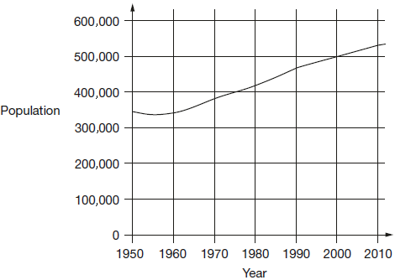
Look at the chart.
In which year did the population first reach 400,000?

How much did the population increase from 1950 to 2000?

What was the population of Cornwall in 2010?

Q2.
This graph shows the distance Alfie and Chen walked in an afternoon. They started at 1:45pm and had two breaks.

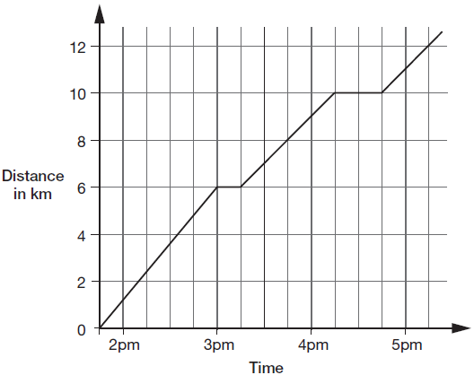

How many kilometres did they walk between the first and second breaks?

At what time did Alfie and Chen start their second break?

Q3.
Two companies sell toys online. They charge to deliver.
Describe the delivery cost of the second company.
The first company is done for you.
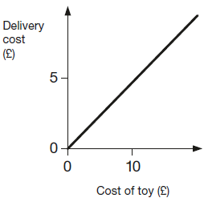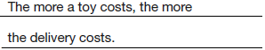
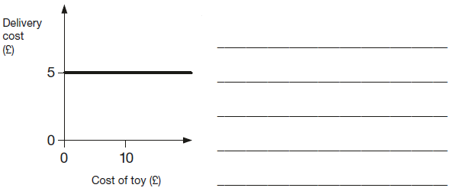

Q4.
The London Eye is a big wheel with pods to carry passengers.

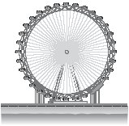
It takes 30 minutes for the wheel to make a complete turn.
This graph shows the height of a pod above the ground as the wheel turns.

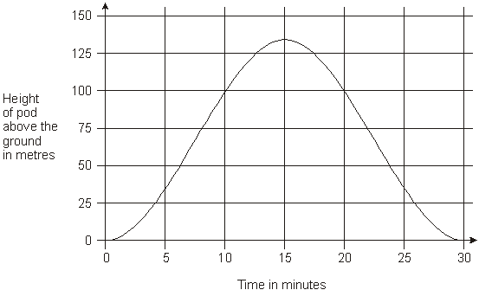
How long from the start does it take the pod to reach a height of 75 metres?

How many metres above the ground is the pod at its highest point?

Q5.
This graph shows the outside temperature from 4pm to 10pm on a day in winter.

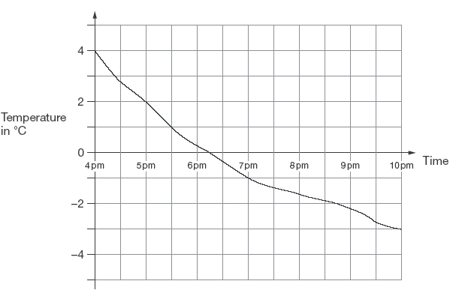

At what time was the temperature –2°C?

How many degrees did the temperature drop from 5pm to 7pm?

Q6.
Alfie and his brother walked from home to their school.
Their school is 2 kilometres from home.
The graph shows information about Alfie’s journey.

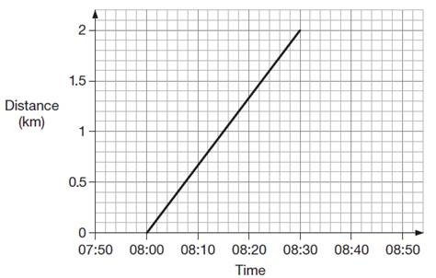

(a) How does the graph show that Alfie walked at a constant speed for all of his journey?
______________________________________________________________
1 mark

(b) Alfie’s brother left home 10 minutes before Alfie.
He arrived at school 20 minutes after Alfie.
He walked at a constant speed for all of his journey.
At what time did Alfie overtake his brother?

Q7.
150 people take part in a walk.
This chart shows the number of people still walking at different times.

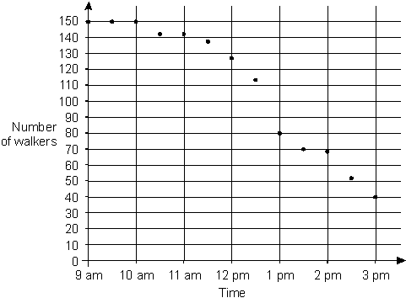

Use the chart to estimate the time when two-thirds of the people are still on the walk.

What percentage of the people who started are still on the walk at 3pm?

M1.(a) 1974 OR 1975 OR 1976
1
(b) A whole number answer in the range 130 000 to 180 000 inclusive.
1
(c) A whole number answer in the range 510 000 to 550 000 exclusive.
Do not accept 510 000 OR 550 000
1
[3]

M2.(a) 4 km
1
(b) 4:15pm
The answer is a specific time
1
[2]

M3.Gives a correct description that indicates the delivery cost is constant, eg:
• The delivery cost is always £5
• The cost is always £5 no matter how much the toy costs
• Delivery stays the same as the cost of toy increases
Accept minimally acceptable explanation, eg:
• It is £5
Accept omission of the actual delivery cost, eg:
• It always costs the same
• The cost is the same
• The cost of the toy does not affect the delivery cost
! Condone correct response with the pound sign omitted, eg:
• It is always 5
! Condone explanations which refer to toys costing up to £20
Do not accept incomplete or ambiguous explanation, eg:
• They are equal amounts
[1]

M4. (a) Answer in the range 7.5 minutes to 9 minutes exclusive.
Accept an answer in the range 21 minutes to 22.5 minutes exclusive.
1
(b) Answer in the range 130m to 140m inclusive.
1
[2]

M5. (a) Answer in the range of 8:40pm to 8:50pm inclusive
The answer is a specific time
1

(b) 3
Do not accept –3
1

M6.Gives a correct interpretation of the graph, eg:
• It is a straight line
• It goes up steadily
• The angle of the line stays the same

• The gradient of the line is constant
Accept minimally acceptable explanation, eg:
• It is straight
• It doesn’t bend
• It is a diagonal

Do not accept incomplete or ambiguous explanations that do not sufficiently imply a constant speed and /
or do not demonstrate the relationship holds for the
entire graph, eg:
• The line goes straight up
• It is not wobbly
• It is level
• Every 5 mins he walks the same distance
• He walks 1km in the first 15 mins and 1km in the second 15 mins

! Values read from graph
Accept, provided it is clear the relationship holds for the entire graph.
Values should be accurate within +/− 0.1km and /
or +/− 2 minutes, eg:
• 0.7km every 10 minutes
• Every 7.5 minutes he walks about half a km

! Calculation of kilometres per hour
Accept values in the range 3.7 to 4.3km per hour inclusive.
1

(b) 08:10
! Accept values between 08:09 and 08:11 inclusive
! Time
1
[2]

M7. (a) Answer in the range 12:30pm to 1:00pm exclusive.
Accept answers with or without ‘pm’.
1

(b) Award TWO marks for the correct answer of 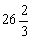% OR 26.6%
Accept 26.6% OR 26.7% OR 26.6 ... % OR 27%
Accept for ONE mark 26%
If the answer is incorrect, award ONE mark for evidence of an
appropriate method, eg
40 ÷ 150 × 100
Answer need not be obtained for the award of the mark.
Up to 2
[3]

