2020 decimal and common fractions consolidation – tricky, but give them a go
Q1.
Write these in order of size, starting with the smallest.
0.5 0.65

smallest
1 mark

Q2.
Write these numbers in order.
One has been done for you.
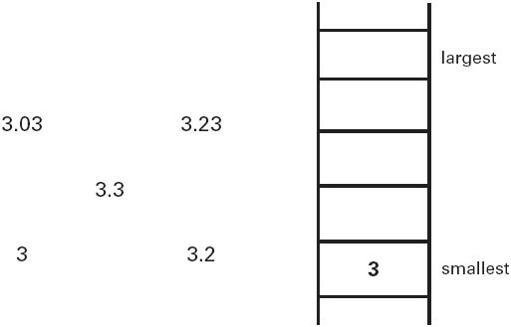
1 mark

Q3.
Write these in order of size, starting with the smallest.
0.34 0.7 43%
smallest
1 mark
Q4.
Write two decimals, each less than 1, which multiply to make 0.1

 |  | × |  | = 0.1

Q5.
Write three decimals, each greater than zero, which add together to make a total of 0.01

 |  | + |  | + |  | = 0.01

Q6.
This is part of a number line.
Write in the missing numbers.
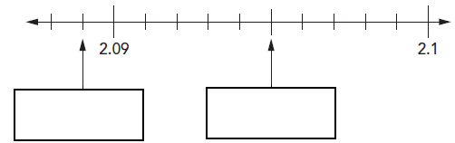

Q7.
Circle the two decimals which are closest in value to each other.
0.9 0.09 0.99 0.1 0.01
1 mark

Q8.
Write the missing number.
1 mark

Q9.
Write the missing numbers.

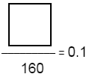
1 mark

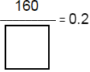
1 mark

Q10.
Here is a number line.
Draw an arrow to show the position of

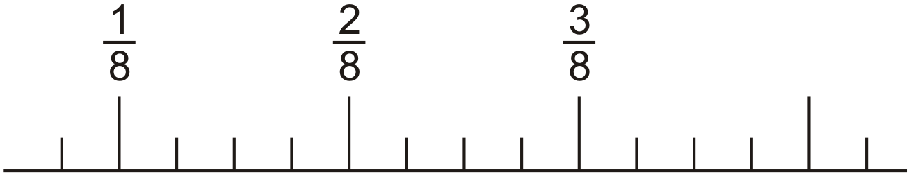
1 mark

Here is another number line.
Draw an arrow to show the position of 0.111

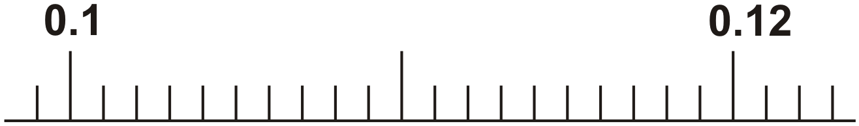
1 mark

Q11.
The sum of two numbers is 5
The difference between the numbers is 0.5
What are the numbers?

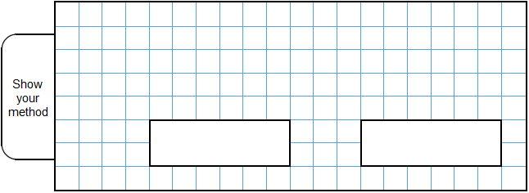
2 mark

Q12.
Write these numbers in order of size, starting with the smallest.

 | 1.01 |  | 1.001 |  | 1.101 |  | 0.11
 | smallest

1 mark

Which one of these fractions is closest in value to ?

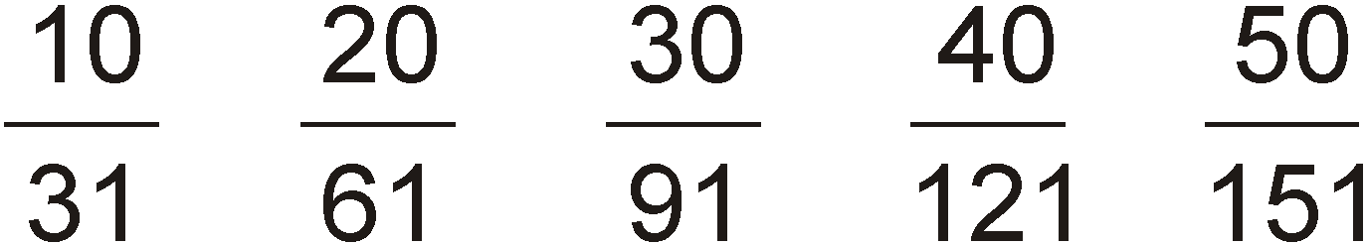
1 mark

Q13.
Part of this number line is shaded.

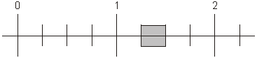

Circle all the numbers below that belong in the shaded part of the number line.
1 mark

M1.Numbers in order, as shown:
0.5 0.65
Accept equivalent decimals, percentages or fractions.
[1]

M2. All four numbers correctly placed as shown:
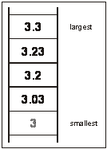
All four numbers must be placed correctly for the award of the mark.
Transcription errors are acceptable only if they do not result in a wrongly ordered list.
[1]

M3. Numbers in order as shown:

0.34 |  | 43% |  | 0.7

Accept use of equivalent fractions, decimals or percentages, eg 0.34, 0.43, 0.7, 0.75
[1]

M4. Any two decimals, each less than 1, with a product of 0.1, eg
OR
Accept negative numbers, eg
[1]

M5. Any three decimals which add to make 0.01, eg
0.005 + 0.002 + 0.003
Accept ++
[1]

M6. 2.089 in first box
1
2.095 in second box
1
Accept equivalent fractions
[2]

M7. 0.9 0.99 0.01
Accept alternative ways of indicating the correct answer eg ticking the correct numbers.
[1]

M8.2.5
Accept equivalent fractions or decimals
[1]

M9. 16
1
800
1
[2]

M10. (a) Arrow or other mark as indicated.
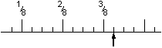
Accept slight inaccuracies provided the intention is clear.
1

(b) Arrow or other mark as indicated.
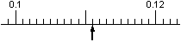
1
[2]

M11. Award TWO marks for a correct answer of 2.25 AND 2.75
Accept the numbers in any order.
Accept the numbers in fraction form.
If the answer is incorrect award ONE mark for evidence of an appropriate method, eg
5 ÷ 2 = 2.5
AND 2.5 + 0.25
AND 2.5 – 0.25
OR trial and improvement showing two attempts, using numbers between 2 and 3,
which either converge towards or straddle the correct answer.
up to 2
[2]

M12. (a)
All in correct order.
1
(b) ⁵⁰/₁₅₁
1
[2]

M13. Two numbers circled as shown:
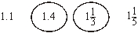
Do not award the mark if additional incorrect numbers are circled.
Accept: alternative unambiguous indications, eg numbers ticked, crossed or underlined.
[1]

