You can answer these questions on your maths paper in your packs.

- Circle the two fractions that are greater than

- mark
These diagrams are all made of squares.
2
Look at each diagram.
Put a tick () if it is not.
)
if exactly
of it is shaded. Put a cross (
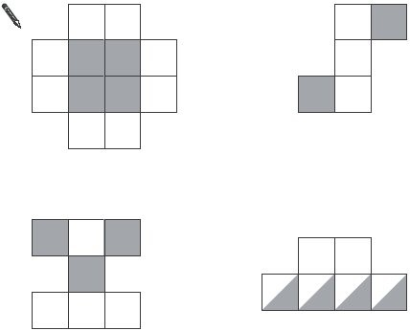
- marks
The diagram is made of squares.
3
What fraction of the diagram is shaded?

- mark
Write the missing numbers.
4
One is done for you.

Improper fraction | Mixed number
____
2
3____
5
- marks
5
Calculate of 840

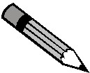
- mark
Karen makes a fraction using two number cards.
6
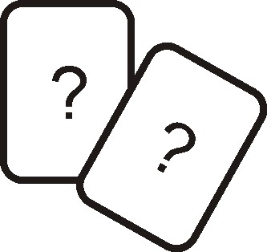
She says,
‘My fraction is equivalent to
One of the number cards is 6’
What could Karen’s fraction be?
Give both possible answers.
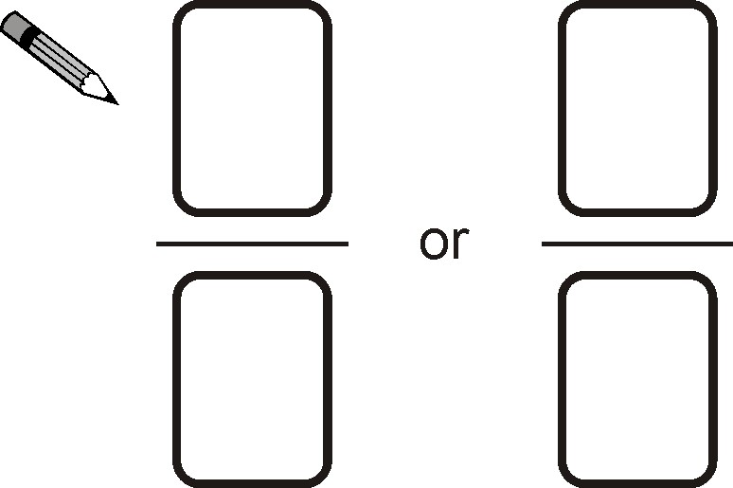
- marks

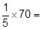
7

1 mark
Here are some number cards.
8
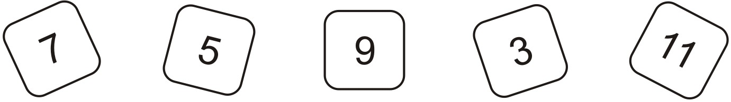
Use two of the cards to make a fraction which is less than .
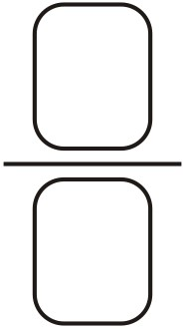
1 mark
How much less than 1 is your fraction?
...............................
1 mark

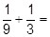
9

1 mark

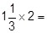
10

1 mark

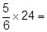
11

1 mark
12
Calculate of 980

1 mark

Mark schemes
Two fractions circled as shown:
1
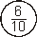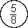

Both fractions must be correct for the award of the mark.
Accept any other clear way of indicating the two correct fractions, such as underlining or ticking.
[1]
Award TWO marks for diagrams ticked or crossed as shown:
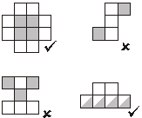
2

Accept alternative unambiguous indications, eg Y or N.
For TWO marks, accept:
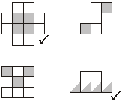
If the answer is incorrect, award ONE mark for three diagrams ticked or crossed correctly.
Up to 2
[2]
3
Accept equivalent fractions.
[1]
4
_____
2
1

3____
5
1

[2]
630
5

[1]
Award TWO marks for both fractions correct as shown:
6
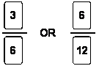
If the answer is incorrect, award ONE mark for one fraction correct.
Accept fractions written in either order.
Up to 2

[2]
14
7
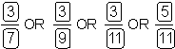
[1] (a)
8

Accept only fraction formed by the cards given.
1
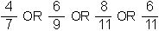
(b)
consistent with part (a).
If part (a) is incorrect, accept working of 1 – (answer to part (a)) provided the numbers used are on the cards.
Accept decimals.
If answer to part (a) is greater than 1, answer to part (b) must be negative.
1

[2]
9

[1]
10
[1]
20
11
[1]
367.5 OR 367½
12
[1]

