Why do I look like me?
 | Mum's Mum |  |  |  |  |  |  | Mum's Dad |  |  |  |  |  |  |  | Dad's Mum |  |  |  |  |  |  | Dad's Dad
 |  |  |  |  |  | Mum |  |  |  |  |  |  |  |  |  |  |  | Dad
 |  |  |  |  |  |  |  |  |  |  |  | Me
Fill the boxes with photos or descriptions of each of your family members listed |  |  |  |  |  |  |  |  |  |  |  |  |  |  |  |  |  |  | Our characteristics (hair colour, eye colour, skin tone, face shape etc.) are all due to our genes, which we inherit from our parents, who inherited theirs from their parents. Look at the photos of your parents and grandparents, can you identify any characteristics you share?

 |  |  |  |  |  |  |  |  |  |  |  |  |  | 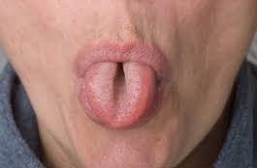
Can you roll your tongue? |  |  |  |  |  |  |  |  |  |  |  |  |  |  |  |  |  |  |  |  |  |  |  |  |  |  |  |  |  |  |  | Can anyone else in your family?
 |  |  |  |  |  |  |  |  |  |  |  |  |  | 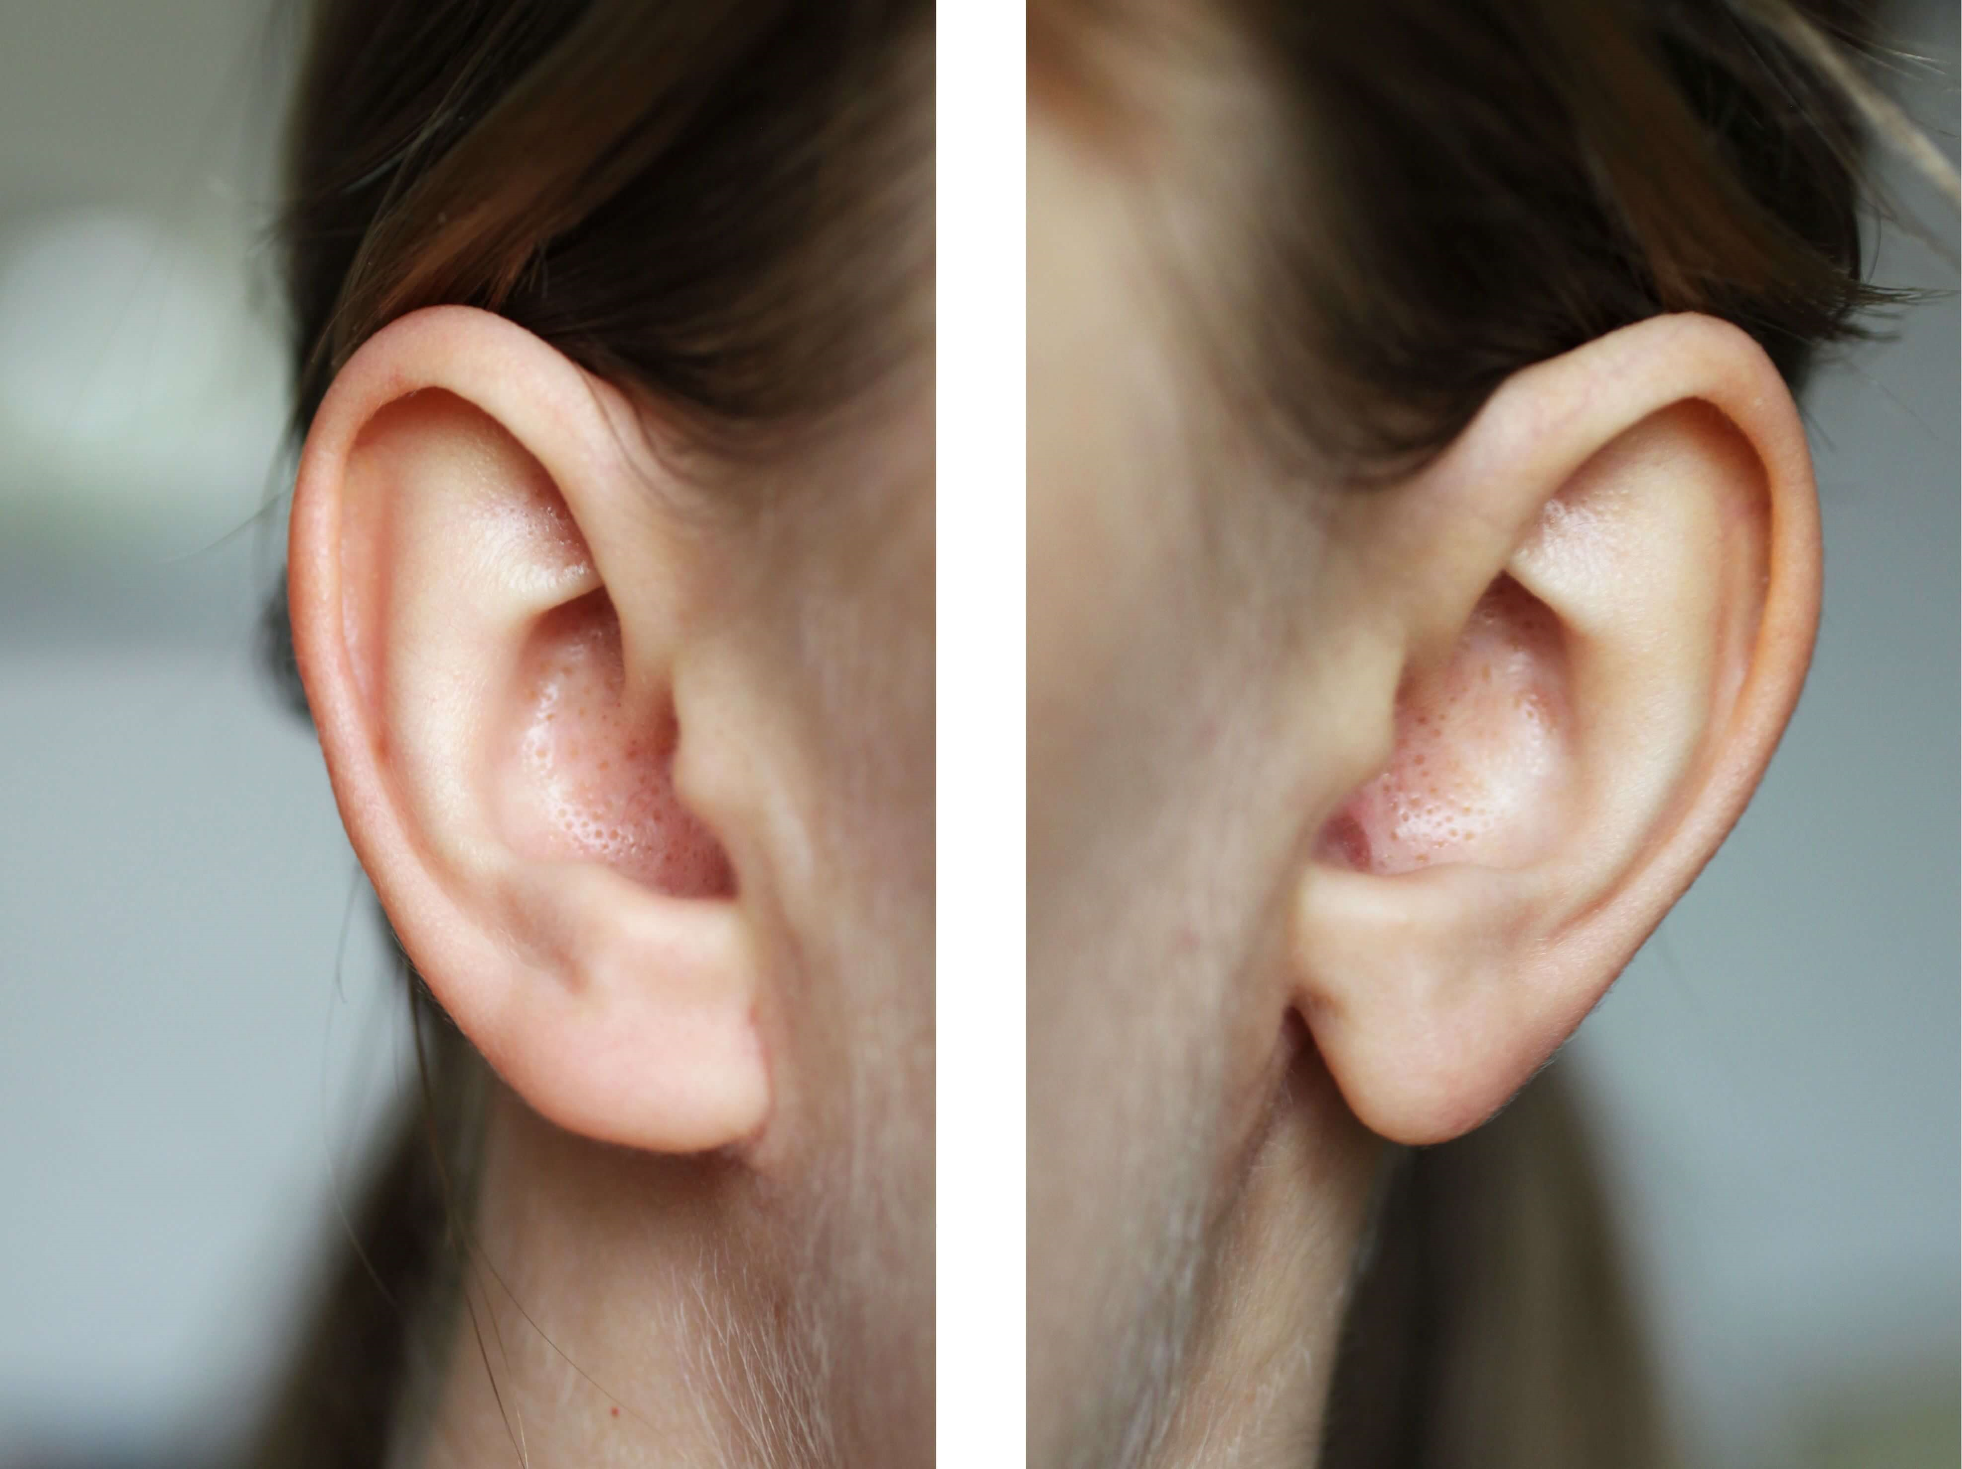
Do you have attached or unattached ear lobes? |  |  |  |  |  |  |  |  |  |  |  |  |  |  |  |  |  |  |  |  |  |  |  |  |  |  |  |  |  |  |  | What about the others in your family?
Watch the video in the link below for an overview of inheritance and variation
https://www.bbc.co.uk/bitesize/topics/zvhhvcw/articles/zp9f4qt

