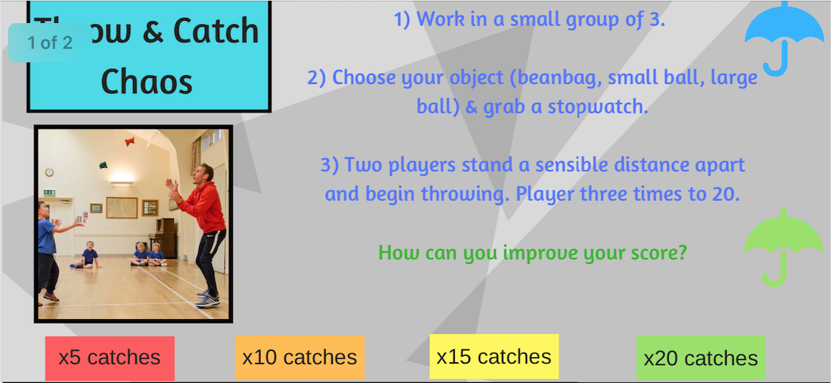

If you haven’t got cones, use jumpers or shoes