Use your box method of working out to find your answers to these questions.

Eg. Find $\frac{3}{4}$ of 4 = 3

|  |  |  |  |
| --- | --- | --- | --- |
|  |  |  |  |

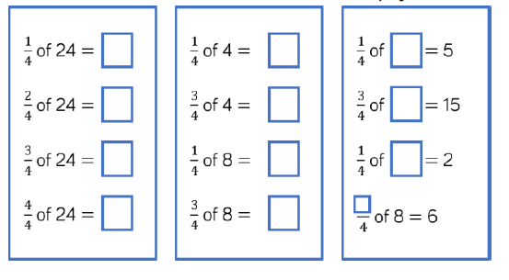

Amir shares 12 bean bags into 4 equal groups.

Use the image to complete the sentence.



One quarter of 12 is equal to _____

Two quarters of 12 is equal to _____

Three quarter of 12 is equal to _____

Four quarters of 12 is equal to ____