Year 3 Homework w/c 23rd March
Here is the home school planning for the week. Don’t forget to also complete 1 or 2 of the Creative projects from your resource pack. There is a different activity for each school subject. Please do not hesitate to email me if you have any questions. I will be available during school hours, Monday to Friday.
Literacy
Last week the children wrote some fantastic persuasive letters from the prospective of King Hrothgar. They were trying to convince Beowulf to come and defeat the monster Grendel. This week, they are going to be writing me a letter! They can choose one of the following to persuade me to do:
- Have a longer golden time each week.
- Not set any homework for a month.
- Organise a summer picnic for Year 3.
Monday
Can the children please select one option from above then create a mind map with some arguments that they could include in their letter. Here is the one that we used for last week’s letter:
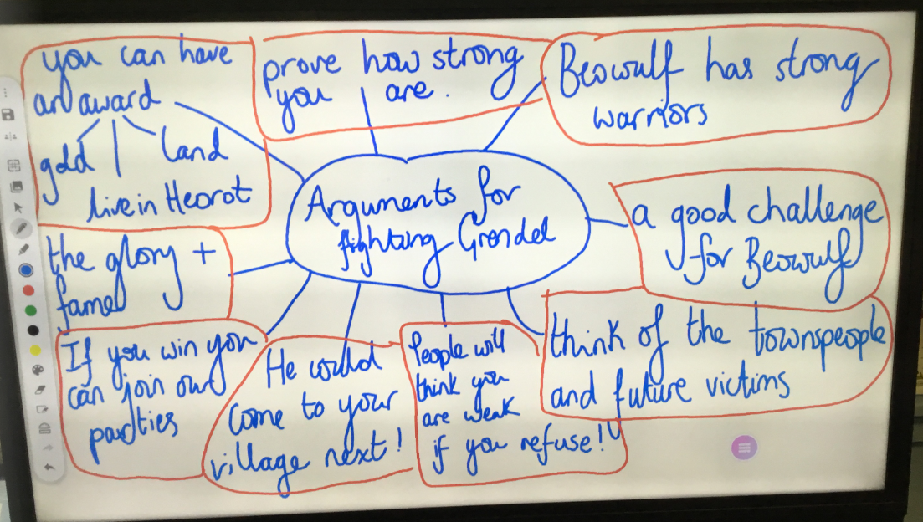
Underneath your mind map, write a rhetorical question that you are going to include in your letter.
Tuesday
Using the persuasive writing vocabulary word mat (in resource pack) and letter example (uploaded on school website) please begin writing the letter on Purple Mash. Write the first two paragraphs then edit it! Don’t forget to use your Year 3 & 4 common exception word mat. Try to set it out as follows:

Introduction paragraph
First Argument
Second Argument

Conclusion paragraph
Wednesday
Please complete the persuasive letter then make sure to self-edit it. Then use the self-assessment checklist (in your resource folder) to ensure that you have included all the key features. There is also a column for your adult to fill in if they have time!

Thursday
Today, you will be working on your reading comprehension skills. Please complete the reading comprehension using the following link:
https://web2.uvcs.uvic.ca/courses/elc/studyzone/330/reading/the-monkey-and-the-crocodile1.htm

Friday
Today, you will be learning about adverbs of time. Start by watching this fun video on adverbs of time:
https://www.youtube.com/watch?v=seaeluxIsqw
Next, read through the PowerPoint. Unfortunately, this is not an interactive PPT so you will need to verbally answer the questions from the slide to your adult. (Adults – the answers are also on the PPT).
Then complete the Adverbials of Time worksheet in your resource pack.

Numeracy
In numeracy, we are half-way through the ‘Length and Perimeter’ topic. We have already looked at different units of measurements and converted between them. We have also used different measuring equipment to take accurate measurements and calculated the perimeter of regular shapes.

Monday LO:
Please start with a refresher 2Do activity on Purple mash – Converts Unit of Measure 2. Then complete the problem-solving questions using this link.
https://tysohie.exampro.net/
Tuesday – adding length
Please answer the questions from the ‘Tuesday Resources’ upload. You can answer these on the squared paper that has been provided or on your own paper. There are some extra challenges on there too! Before completing the calculations, make sure you have converted the lengths to the same unit of measurement, i.e. all mms.
Wednesday –subtracting lengths.
Please solve the Fluency and Problem-solving questions on subtracting lengths. For the first few questions, you will be asked to use a bar model. A bar model is a visual strategy to help solve number problems. The number on the top bar represents the total of the numbers below.
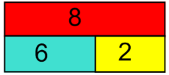
i.e. 6 + 2 = 8 2 + 6 = 8
8 – 6 = 2 8 – 2 = 6

Thursday – measuring perimeter
Using the ruler provided in your resource pack, or any other measuring equipment you have at home, please choose at least 5 household objects and measure the perimeter of them. You could record them in a table like this:
Object | Jottings (working out) | Perimeter (m/cm/mm)
Photo frame | 15 + 8 + 15 + 8 = 46 | 46cm
Then complete the 2Do set for you on Purple Mash – 2D shape perimeters.

Friday – measuring perimeter 2
Please complete the 2Do set to you on Purple Mash – Perimeter. This is a continuation of yesterday’s work.
Then use: http://toytheater.com/area-perimeter-explorer/ to play around with creating regular and irregular shapes.
Can you create a shape with a perimeter of:
- 8cm?
- 20cm?
- 36m?
Finally, play the game:
https://toytheater.com/perimeter-climber/

