Year 3 Homework w/c 30th March
Numeracy
Monday
The children were introduced to perimeter last week, so should be clear on how to calculate and measure the perimeter of regular shapes. First, watch the SuperMover video:
https://www.bbc.co.uk/teach/supermovers/ks2-maths-measurement-with-max-and-Harvey/zdv2cqt
Then move onto the Fluency, Reasoning and Problem-Solving questions.
Extension game:
https://www.sheppardsoftware.com/mathgames/geometry/shapeshoot/PerimeterShapesShoot.htm
Money topic
The children that were in school on Friday 20th March will have, in their Home-School packs, examples of different methods of calculation which they can use in this topic, including part whole models and bar models. All children should also have a strip of paper with different coins on, showing their value. I will attach this onto the bottom of this document for those who do not have it. Uploaded onto the class page will also be some Mastery maths challenge questions for your child to complete throughout the week for an extra challenge!
Tuesday
Please complete the Purple Mash activities assigned to you as a brief introduction on the money topic.

Wednesday – Converting pounds and pence
Use the following game to find different combinations of coins:
https://www.topmarks.co.uk/money/toy-shop-money
You should be using the ‘Mixed Coins’ then ‘Exact Money’ option.
Then complete the questions on from the ‘Wednesday maths resources.’ You can type the answers on the word document.

Thursday
Using a part whole model and bar model, convert these amounts between pounds and pence (pence at the bottom and the total on top!). This should help you when adding money later

£3.50 £4.75

300p 50p 400p 75p

An additional game if you want to continue playing money games:
https://www.topmarks.co.uk/money/coins-game

Friday
Please answer these test style questions to consolidate your learning from this week.
https://yeziwid.exampro.net/

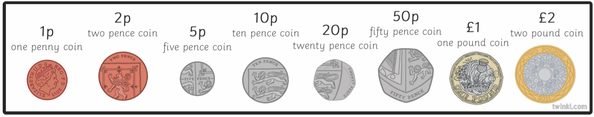

Literacy – Writing some instructions
Monday – imperative verbs
Play a game of ‘Simon Says’ – this is a chance to practice using imperative verbs and boss your family around!
Play the game:
https://kidseslgames.com/grammar%20games/Imperatives/Imperatives%20Football%20Game.html
Then complete the Imperative verbs worksheet uploaded onto the class page.
Tuesday
Open the instruction example text – read through it and make a note of all the key features that you spot. (Parents – we have completed this activity for different text types multiple times throughout the year). For example: title, numbered instructions. Then, open the answers document and mark your work.
Ext: Make a note of all the imperative verbs on the ‘How to wash your elephant’ document.

Wednesday & Thursday
Watch the video on this page. Its is all about writing instructions in the form of a recipe.
https://www.theschoolrun.com/instruction-texts
Today and tomorrow, you are going to be writing a set of instructions! Please complete this using the 2Do: Instructions program. These can either be on:
- How to build a den
- A recipe for your favourite meal
- How to play a game (you can either choose a game or create your own!)
- How to build a Lego model
Don’t forget to include the key features! Remember the adverbs of time from last Friday’s literacy – you should start all steps with a fronted adverbial (don’t forget the comma!). I have uploaded a vocabulary word mat for you to use.
Once you have completed, use the checklist to ensure that you have included all the key features.
EXT: Use at least 3 different prepositions in your instructional text.

Friday
Please complete the reading comprehension using the following link:
https://hieuuuf.exampro.net/
In the past few weeks, we have been working on answering ‘Find and copy’ questions. I have attached the mark scheme to the questions.

Topic homework
I understand that I have already set some creative homework activities for you to complete (1 or 2 per week). I am also going to set one additional PurpleMash activity each week. These will either link to our topic ‘The Anglo-Saxons’ or will be a refresher on something we have already covered in year 3 in either numeracy or literacy.

This week, please compare an Anglo-Saxon diet to a modern-day diet. Complete some research on Anglo-Saxon food. Begin by watching the quick video:
https://www.youtube.com/watch?v=sRZYfNDzfCo
Here are some good websites for your research!
- https://www.dkfindout.com/uk/history/anglo-saxons/what-did-anglo-saxons-eat/
- http://www.primaryhomeworkhelp.co.uk/saxons/food.htm
- http://www.earlybritishkingdoms.com/kids/food_drink.html
Present your findings using the 2Do set for you on Purple Mash: Anglo-Saxon: food
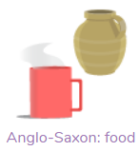
If you would like to present any additional information on this topic, feel free to use the Blank Leaflet app on PurpleMash.
Additional Notes
- Audible have released hundreds of kid’s books for free – have a look!
- David Walliams has also released
- https://www.duolingo.com/ is a brilliant website which can be downloaded as an app on your child’s tablet. It provides free language lessons. Please use if you would like your child to continue developing their French – I’m sure they will all enjoy it!
- Joe Wicks is releasing daily homework outs for children (and adults!) to complete. He is doing this on his YouTube channel.

