Wednesday resources – subtracting lengths
Fluency
- 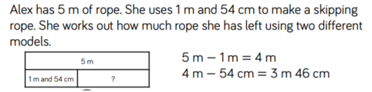
Use a bar model to solve:
- Mrs Parnells’s ball of wool is 10m long. She uses 4m and 28cm to knit a scarf. How much does she have left?
- A roll of tape is 3m long. If Mrs Richardson uses 68cm of it wrapping presents, how much will she have left?
- Mrs B has a chocolate that is 2 ½ m long. If she eats 1m 15cm of it, how much does she have left?
Problem Solving
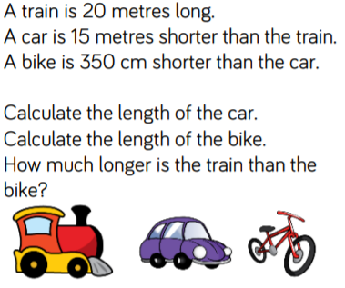

Extra challenges!
