Tuesday Resources – Adding Lengths

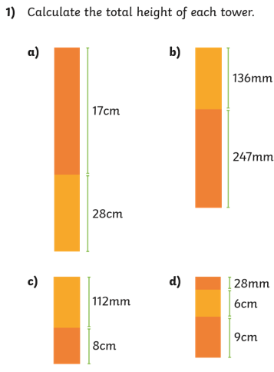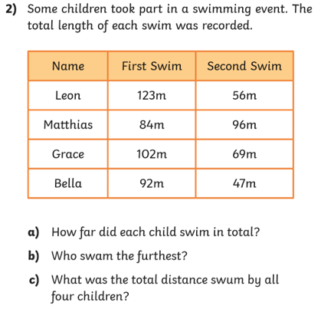

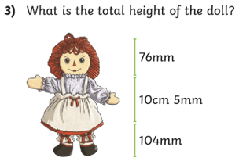

Extra challenge!

Can you then measure the height of your family?

What is the total height?

What is the difference between the tallest and shortest person in your family?

How much taller is your Mum than you?

