Reading
Please continue reading each day with your child. There are e-books available in the different bands from this website: https://home.oxfordowl.co.uk/
Please also use the comprehension questions when reading with your child. These should be in the pack which came home with the children on Friday 20th March.
I am also attaching a reading task – The image based questions are designed to encourage children to only answer the questions using the evidence in front of them. We have completed activities like this in class so they should be familiar to the children.

What do you think is happening in the picture?

#
How do you think the people feel? Why?
What are the people waiting for?

Why is one person running on their own?

Possible answers:
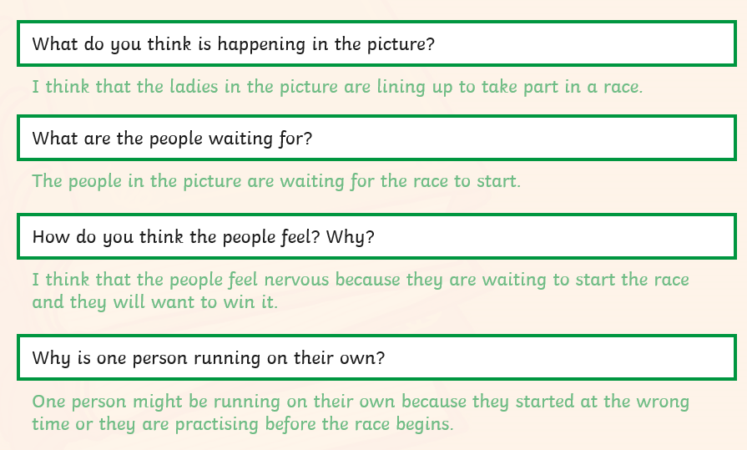

Extension: What other questions can the children think of which they could answer using just the evidence in the picture?

