Homework/Extension
Step 6: Compare and Order Fractions Greater than 1
National Curriculum Objectives:
Mathematics Year 5: (5F3) Compare and order fractions whose denominators are all multiples of the same number
Differentiation:
Questions 1, 4 and 7 (Varied Fluency)
Developing Circle the greatest fraction. Includes fractions where the denominators are multiples of the same number (halving and doubling only). Pictorial representations used. Expected Circle the greatest fraction. Includes fractions where the denominators are multiples of the same number. Pictorial representations used.
Greater Depth Circle the greatest fraction. Includes fractions where the denominators share a common factor or common multiples.
Questions 2, 5 and 8 (Varied Fluency)
Developing Compare two improper fractions using <, > or =. Includes fractions where the denominators are multiples of the same number (halving and doubling only). Pictorial representations used.
Expected Compare two improper fractions using <, > or =. Includes fractions where the denominators are multiples of the same number. Pictorial representations used.
Greater Depth Compare two improper fractions using <, > or =. Includes fractions where the denominators share a common factor or common multiples.
Questions 3, 6 and 9 (Reasoning and Problem Solving)
Developing Compare and order three improper fractions and explain. Includes fractions where the denominators are multiples of the same number (halving and doubling only).
Pictorial representations used.
Expected Compare and order three improper fractions and explain. Includes fractions where the denominators are multiples of the same number.
Greater Depth Compare and order three improper fractions and explain. Includes fractions where the denominators share a common factor or common multiples.
More Year 5 Fractions resources.
Did you like this resource? Don’t forget to review it on our website.

classroomsecrets.co.uk
Homework/Extension – Compare and Order Fractions > 1– Teaching Information
1. Circle the greatest fraction.

- 1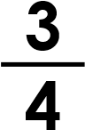 C. 1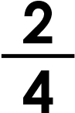
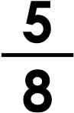
- 1 VF
D
HW/Ext
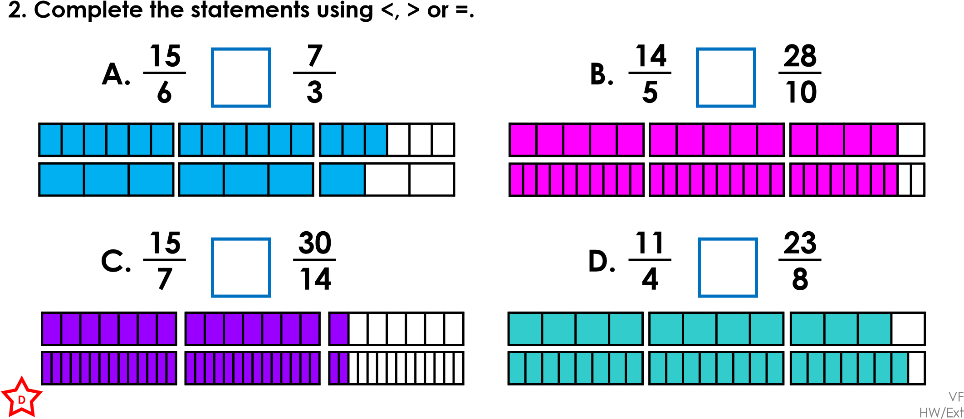
3. Lena, Zane and Amy are swimming lengths of the swimming pool. They have expressed their distances as improper fractions.
I swam of the
pool.
I swam of the
pool.
I swam of the
pool.
9
3
14
6
16
6
Lena
Amy
Zane
Put their distances in ascending order. Explain your answer. _{RPS}
D
HW/Ext

classroomsecrets.co.uk
Homework/Extension – Compare and Order Fractions > 1 – Year 5 Developing
4. Circle the greatest fraction.

- 2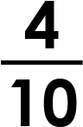 C. 2
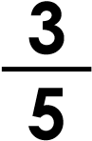
- 2 VF
E
HW/Ext
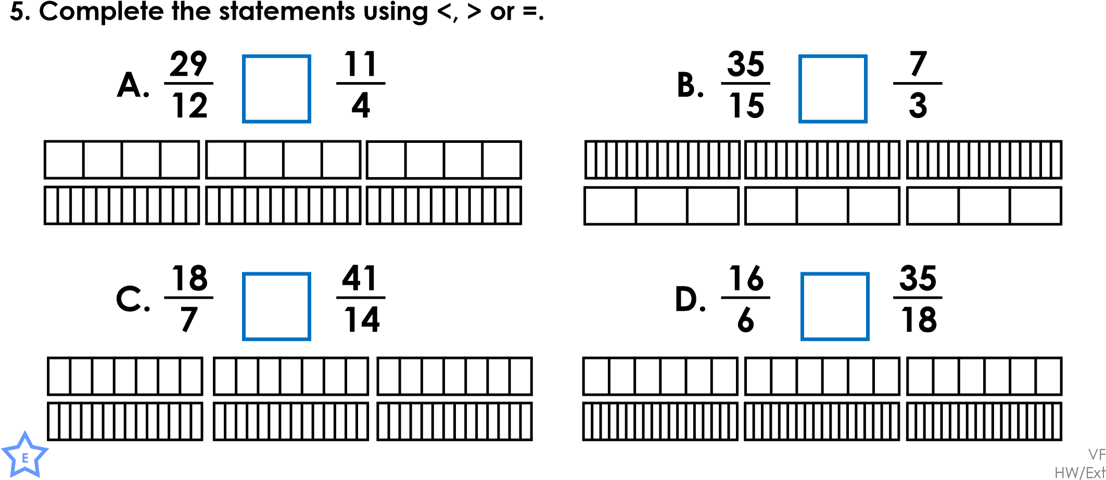
6. Jack, Aliyah and Mckenzie are running round their school track. They have 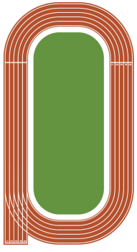expressed their distances as improper fractions and mixed numbers.
Jack
Aliyah
I ran of the
track.
I ran of the
track.
33
16
2
1
2
I ran of the
track.
17
8
Mckenzie
Put their distances in ascending order. Explain your answer. _{RPS}
E
HW/Ext

classroomsecrets.co.uk
Homework/Extension – Compare and Order Fractions > 1 – Year 5 Expected
7. Circle the greatest fraction.
A. 2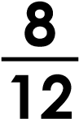 B. 2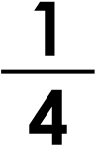
C. 2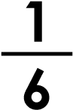 D. 2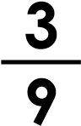
VF HW/Ext
GD
8. Complete the statements using <, > or =.
A. B.
C. D.
VF HW/Ext
GD
9. Freya, James and Lucy are filling beakers for a science experiment. They have expressed their volumes as improper fractions and mixed numbers.
I filled of the
beakers.
I filled of the
beakers.
16
8
33
12
Freya
James
I filled of the
beakers.
2
4
16
Lucy
Put their volumes in ascending order. Explain your answer. _{RPS}
GD
HW/Ext

classroomsecrets.co.uk
Homework/Extension – Compare and Order Fractions > 1 – Year 5 Greater Depth

Homework/Extension
Compare and Order Fractions Greater than 1
Developing
- A
- A. > B. = C. = D. <
- Amy 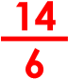, Zane 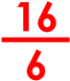, Lena 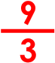 = 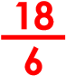
Expected
- B
- A. < B. = C. < D. >
- Aliyah 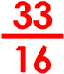, Jack 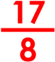 = 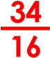, Mckenzie 2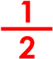 = 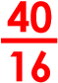
Greater Depth
- A
- A. < B. = C. = D. >
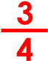
- Various answers, for example: James 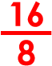 = 2, Freya 2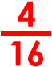 = 2, Lucy 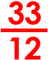 = 2

classroomsecrets.co.uk
Homework/Extension – Compare and Order Fractions > 1 ANSWERS

