Number bonds to 20 questions – Either use the space under each question to write the answer or the squared paper in the pack.

- If you know 4 + 6 = 10 What will 14 + 6 be and why?

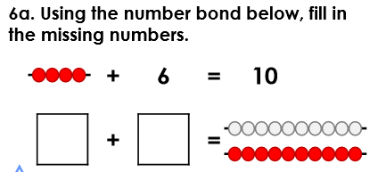

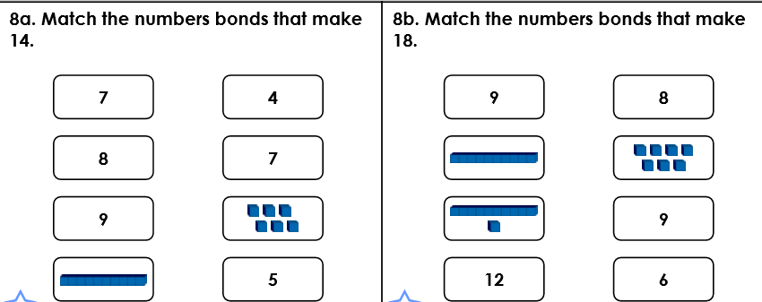

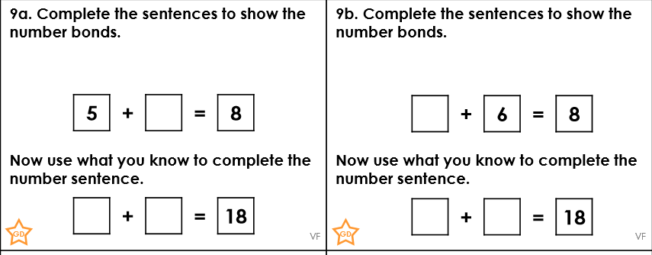

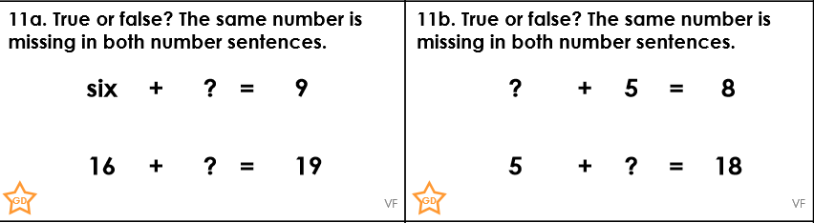

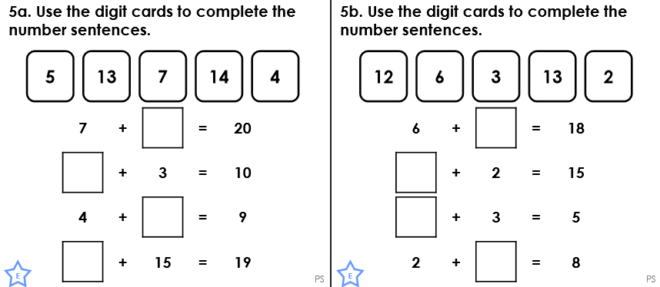

Challenge questions

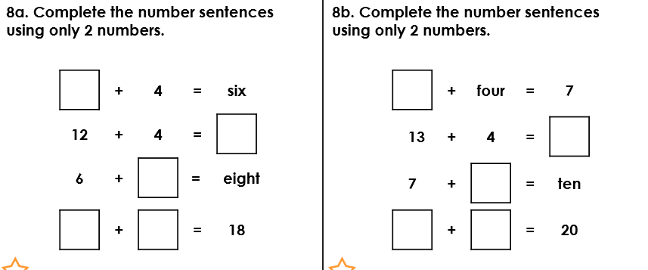

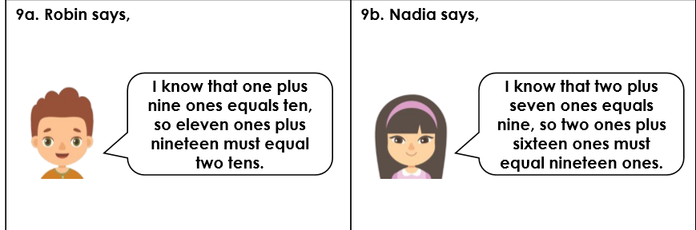
Is he correct? Is she correct?

- There are double the amount of number bonds to 20 than there are number bonds to 10.
Prove it – can you work in a systematic approach?

Answers
- 20 because the number you are starting with is 10 more so the answer will be ten more.
- 14 + 6 = 20 or 6 + 14 = 20

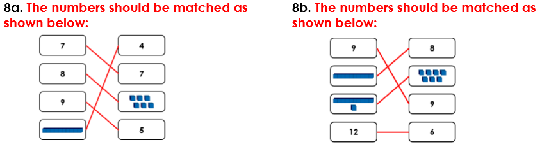

- A) True b) False – The missing number in the first calculation is 3 and the missing number in the second calculation is 13.

Challenge questions:

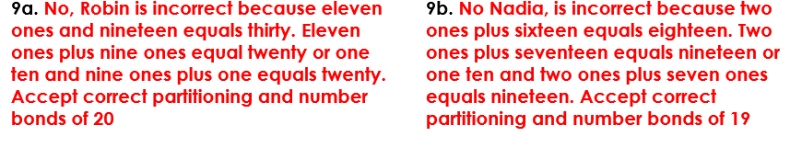

- False there are 11 number bonds to 10 and 21 number bonds to 20.

