My Marvellous Family!
This week I have planned a series of writing tasks around your family! I am sure there can be other English opportunities too, e.g. you could share a chapter book together, read to an older/younger sibling, or even a pet!
This list is not exhaustive at all – maybe you have your own ideas for a writing task you could undertake? Don’t forget to celebrate your learning with me – email it across and I promise I will reply!
Write a recount of your day.  This could be used in history one day to show what happened during this period. | Write a character description about a member of your family. | Write a story involving members of your family.  Do they have to defeat a monster? Or find something they have lost? | Write a set of family rules.  Ensure that they are positive, begin with ‘We always’ rather than ‘We do not…’
Write a letter to a member of your family that you have not seen this week. | Write a set of instructions for a game, craft, recipe you love to do with a member of your family.  If you can email them to me, I could then send them to other members of the class to also complete. | Spend some time looking back through old photographs. Choose one of your favourite past events, and write a newspaper report about it.  Purple Mash has a newspaper template that you could use if you wanted to type up your report after you have written it in draft form. | For all these tasks, please try to think about and include:  - Write in paragraphs, grouping related material together.  - Expanded noun phrases with prepositional language  - Fronted adverbials  - Ensure standard English forms for verb inflections, e.g. we were instead of we was, I did instead of I done.  - Proof read your work for spelling and punctuation errors  - Subordinate clauses
Look very carefully at the Year 3 / 4 Common Exception Word List.  Identify 8 spellings that you are still working on and focus on these this week. | 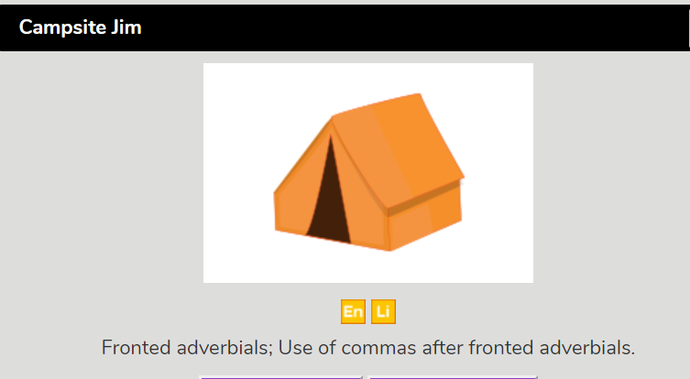  Purple Mash ‘To Do’ Campsite Jim | 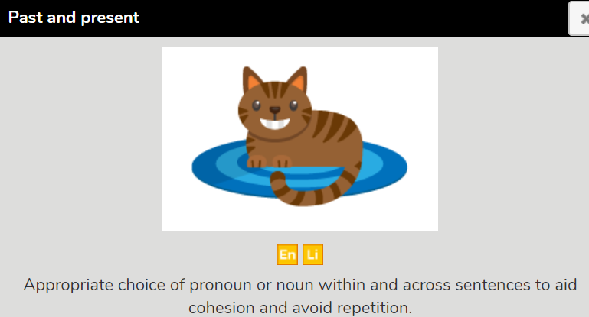  Purple Mash ‘To Do’ Past and Present | Spelling rule: adding the suffix -ation  -ation is added to a verb to form a noun.  If the verb ends in a silent ‘e’, this e is dropped before adding -ation.  When a word ends in a ‘y’, change to an ‘i’ before the suffix -ation is added.  