1. 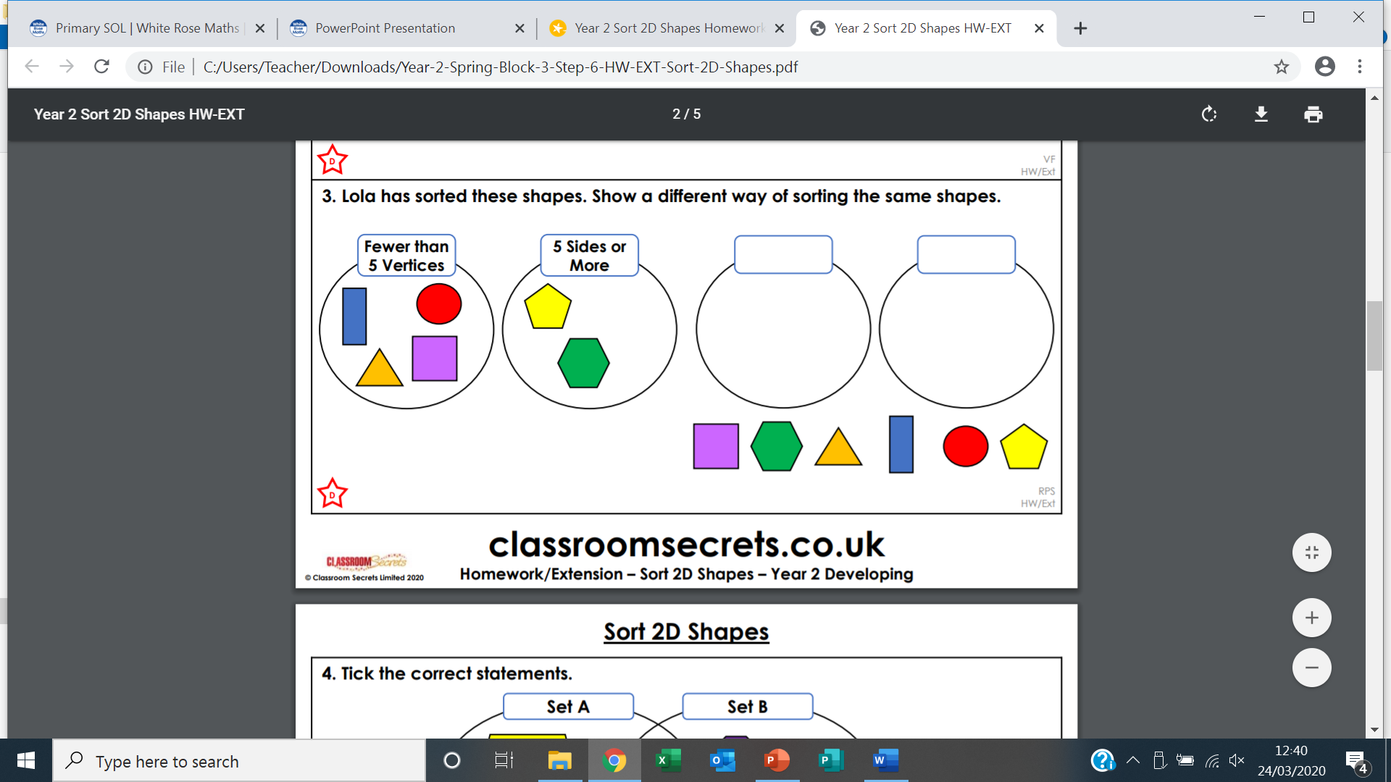Lola has sorted these shapes. Show a different way of sorting the same shapes.
2. Tick the correct statements?

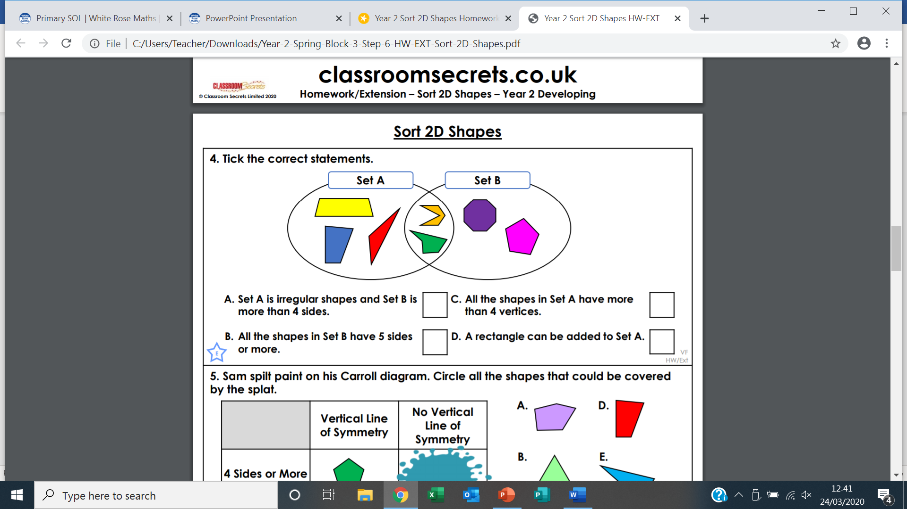

1. 