1. 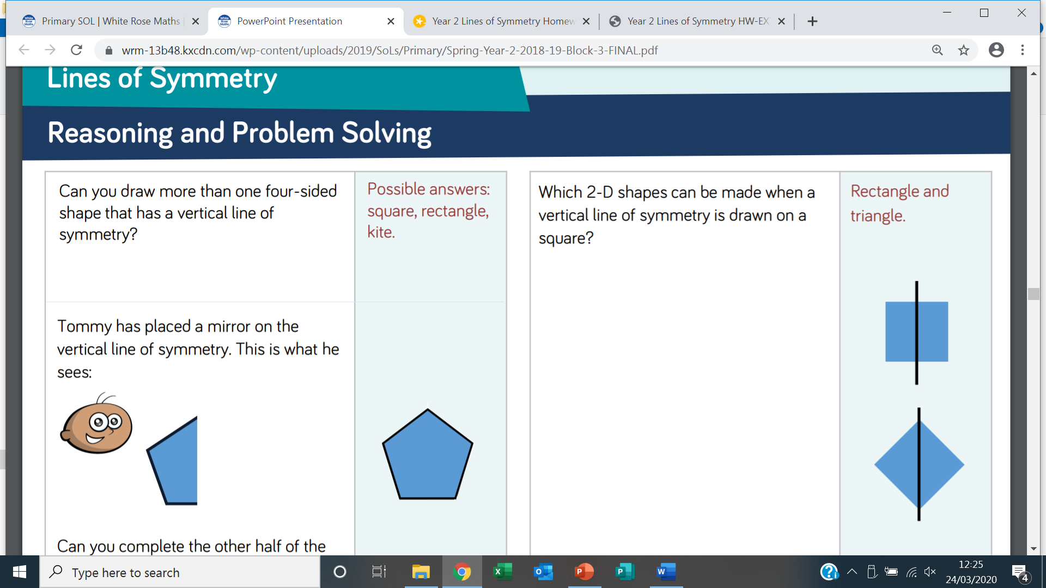

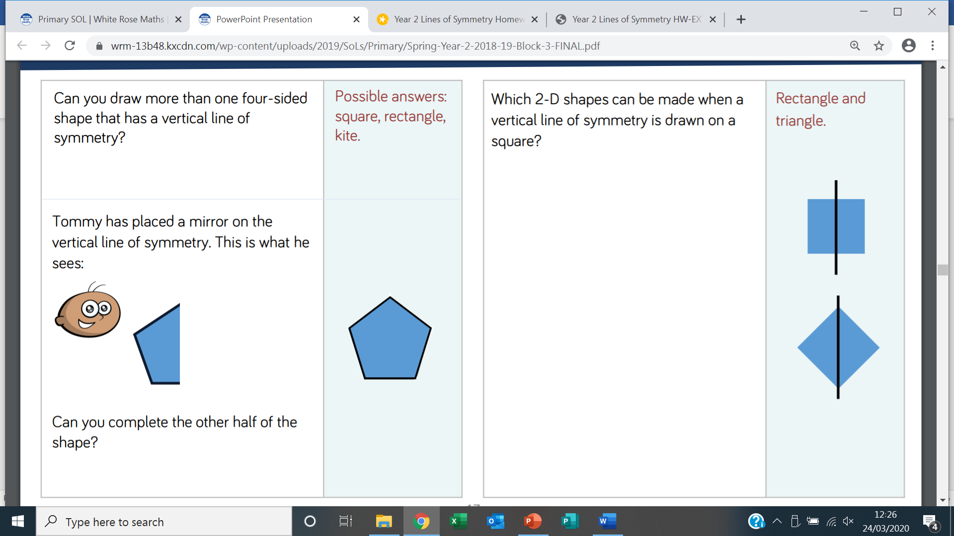

1. Jessica has spilt paint on some shapes which all have horizontal and vertical lines of symmetry. Name the shapes.

