- On your Maths paper, write down the name of each 2D shape. The word bank below will help you spell them accurately.

A | B | C | D | E | F | G

Triangle | Square |  | Rectangle |  | Circle
Pentagon |  | Octagon |  | Hexagon

- On your Maths paper, write down the name of each 3D shape. The word bank below will help you spell them accurately.
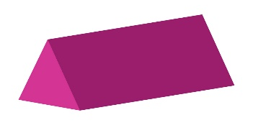
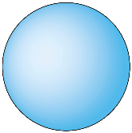
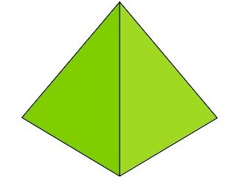

A | B | C | D | E | F

Cube | Square based pyramid | Cuboid | Cylinder
Sphere |  | Prism

- Go on a 2D and 3D shape hunt around your home. Create a tally of the shapes you see. Can you see any pentagons? Can you see any octagons? Can you see any hexagons? What was the most common shape?

