While you are at home pick 1 or 2 activities a week to complete.
This Photo by Unknown Author is licensed under CC BY  History  You are living history. As a historian record an account of what it is like to live during the Coronavirus. You could include:  What is Coronavirus?  How has it changed your life?  When did you first hear of it and how?  What you are doing day to day  Interviews of family members.  What is fun about it?  What is bad about it?  How do you feel about it? | Art  Create a piece of Easter artwork.  It could be connected to the Easter story, how we celebrate Easter such as giving eggs or connected to Spring and new life.  You should make sketches to help you plan your final piece.  Think about what you want to create, what you will include and what colours and affects you will use.  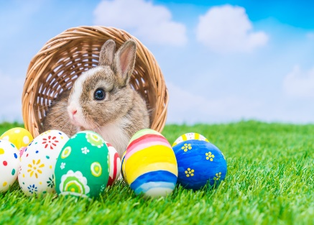  This Photo by Unknown Author is licensed under CC BY-SA-NC | 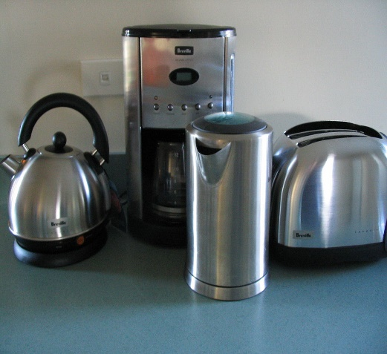  This Photo by Unknown Author is licensed under CC BY-SA  Science  Identify and list the different appliances in your home that run on electricity.  You could categorise them as those that use a battery or not or which rooms they are commonly found in.  How can you keep yourself safe when using electrical appliances? For example, if my toast gets stuck in the toaster how can I get it out safely?
Design and Technology  Read and follow a recipe. Perhaps you could take a lead on making a meal for the family.  Take a photo of the food and/or write a short description of what you did. What did you find easy or hard.  Did you enjoy making it?  This Photo by Unknown Author is licensed under CC BY-SA-NC | 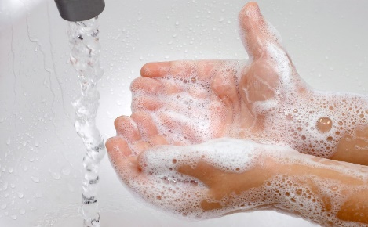  This Photo by Unknown Author is licensed under CC BY-SA-NC  Physical Education  Write a short explanation of how we should wash our hands and why it is so important.  Why are we being asked to wash are hands very carefully at the moment?  Include the key word bacteria.  You might like to watch Newsround if you need some help with this. | Geography  Watch the weather forecast for at least 3 days.  Record what weather is forecast. Then keep your own record of the weather for comparison.  Was the forecast accurate?  Why are weather forecasts important? How might they help a farmer or keep people safe from natural disasters? Can you give examples to prove you point?  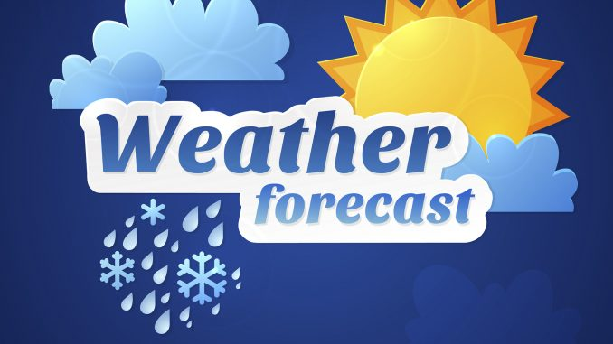  This Photo by Unknown Author is licensed under CC BY-NC

