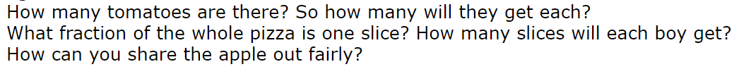
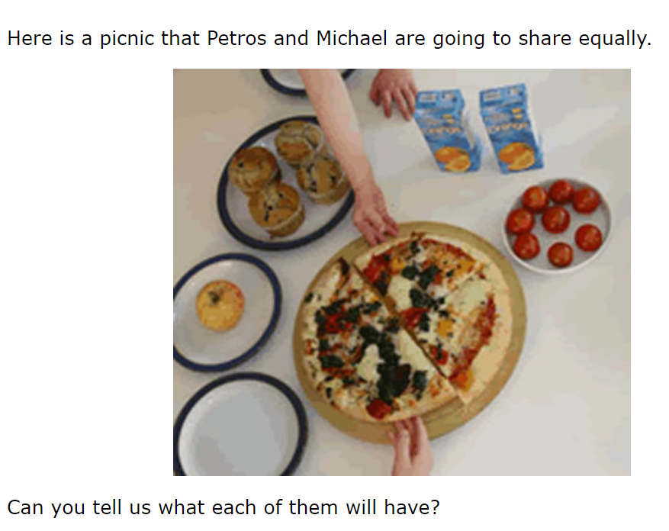
Family Feast

Extension
Can you plan a family picnic? How will you divide up the food? Will all the items be shared lout fairly?

Find a way to record this, e.g. photograph, diagram, written explanation

