Creative maths!
Could you create a poster that represents your day in fractions?

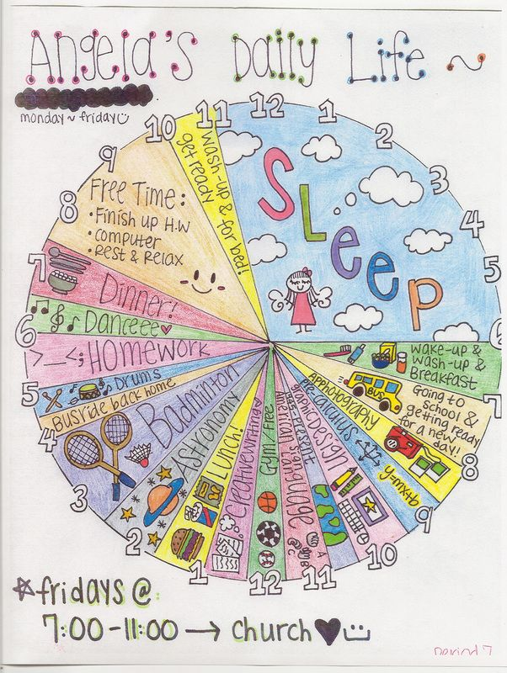

Other activities:
Fractions: https://www.mathsisfun.com/ Go to Numbers-fractions menu-comparing fractions. Scroll down to the section that is titled ‘The same denominator method’ this is what we have been focusing on in class……have a go at the questions.

Time: For those of you that are not confident with telling the time, you could use ‘this time’ to practise! This on-line game is helpful: https://www.primarygames.com/time/question1.htm Throughout the day, ask someone at home to regularly ask you what the time is.

