1) Count how many pieces are there altogether - this is the NUMERATOR!
Chocolate | Improper Fraction | Mixed Number
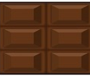 | 10  6 | 1 4  6
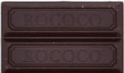
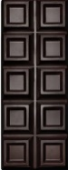
2) Count how many pieces are there in 1 whole bar - this is the DENOMINATOR!

