1) Count how many pieces are there altogether - this is the NUMERATOR!
Chocolate | Improper Fraction | Mixed Number
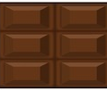 | 10  6 | 1 4  6
 | 15  6 | 3  2 6
 | 15  6 | 3  2 6
 | 10  4 | 2 2  4
 | 13  4 | 3 1  4
 | 7  4 | 3  1 4
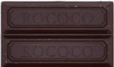 | 5  2 | 1  2 2
 | 3  2 | 1 1  2
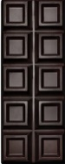 | 15  10 | 5  1 10
2) Count how many pieces are there in 1 whole bar - this is the DENOMINATOR!

