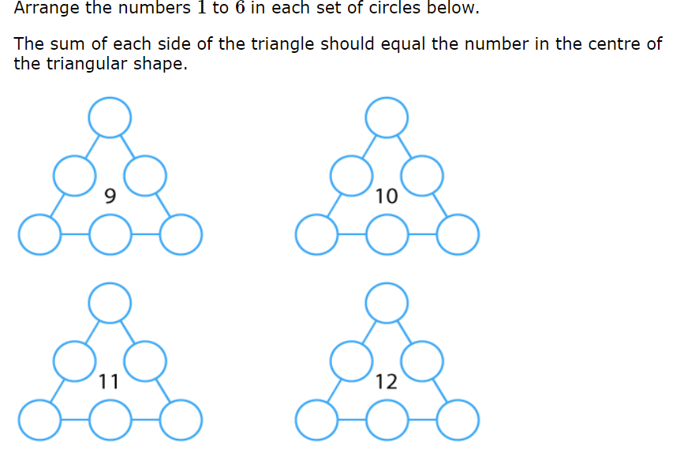

**Key questions**

What will you try first?  
Why did you put that number there?  
Tell me about how you found that solution.  
Is there only one solution?

On the next page are blank triangles, so children can try out different approaches to get the answer.

Hint: When working out a solution, I found it useful to use the whole - part method we have used in class:

I then drew different whole – part models for the number I was trying to make each time and then went from there seeing which numbers were the most popular.

10

4

1

5

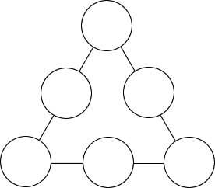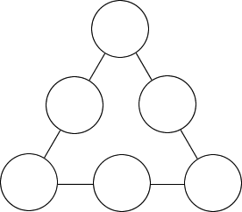





Solution:

1 possible solution:

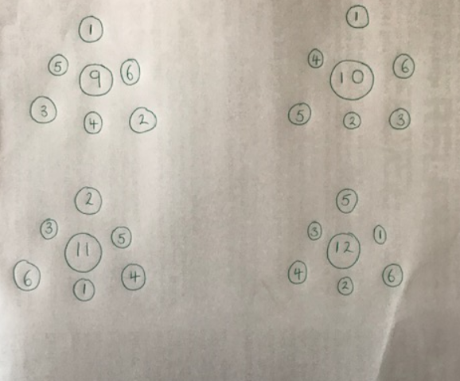

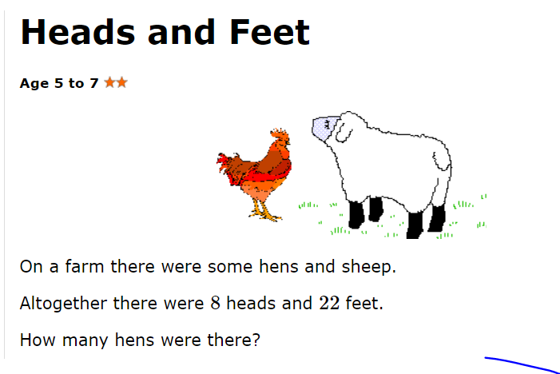

Hint:

How many legs would eight hens have?  
How many legs would eight sheep have?  
Then try a different amount of hens and sheep and calculate the number of legs.

Solution:

Answer = 5 hens.  
5 hens would have 10 feet.  
3 sheep would have 12 feet.  
10+12= 22