Thursday Resources
Please fill in the missing amounts on the part whole and bar models.

£4.25 £ £8.70

400p 500p 55p 70p

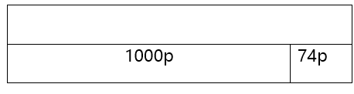
£5.05
500p

£7.89
89p

