Wednesday resources
Please choose either:
Mild (questions 1-3)
Spicy (questions 4-6)
Hot (questions 7-9)

If you are finding one too tricky, move onto the Mild questions. Equally, if you are finding the questions too easy, please move up to the next challenge.

Mild

£ __________and ______ p
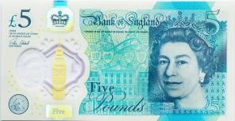
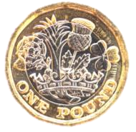
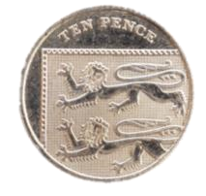
1. Complete the representations below using pounds and pence so that the statements are true.
A.<
£6 and 10p
£ __________and ______ p
B. 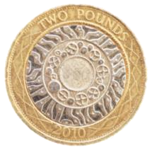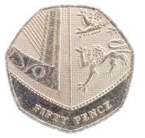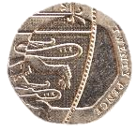 >
£2 and 75p
VF HW/Ext
2. Tick the representations that have a total of £2 and 10p.
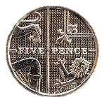A. B. C. 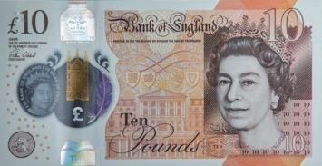
VF
HW/Ext
3. Annabelle has the coins below in her money box.
Using some of these coins, I can make
twenty
-
five pence.
Is she correct? Explain how you know.
RPS HW/Ext

Spicy

4. Complete the representations below using words, pounds and pence or coins and notes so that the statements are true.
- 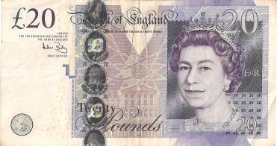>
- £11 and 76p <
VF HW/Ext
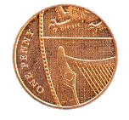
5. Tick the representations that have a total of £7 and 81p.

A.
Seven pounds and
B.
C.
eighty-one
pence
VF HW/Ext
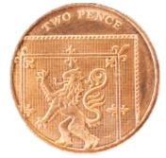
6
. Harry has the coins below in his money box.
Using some of these coins, I can make fifty
pence in three different ways.
Is he correct? Explain how you know.
RPS HW/Ext

Hot

7. Complete the representations below using words, pounds and pence or coins and notes so that the statements are true.
Three pounds and fourteen pence
A. £5 and 25p >
G
B.
Twelve £1 coins, one 50p
coin and six
10p coins
>
=
8. Tick the representations that have a total greater than £9 and 50p but less than £12 and 50p.
B.
A. C.
five £2 coins,
two £5 notes four 20p coins, and eight 2p four 5p coins coinsand seven 1p coins.

9
. Sadiq has the coins below in his money box.
Using some of these coins, I can make £1
and 45p pence in three different ways.
Is he correct? Explain how you know.
RPS HW/Ext

