**Maths for this week:**

**PLACE VALUE**

Please ignore the number sequencing of the questions. I have attached the answers for marking too (I hope it makes sense!).

FLUENCY:

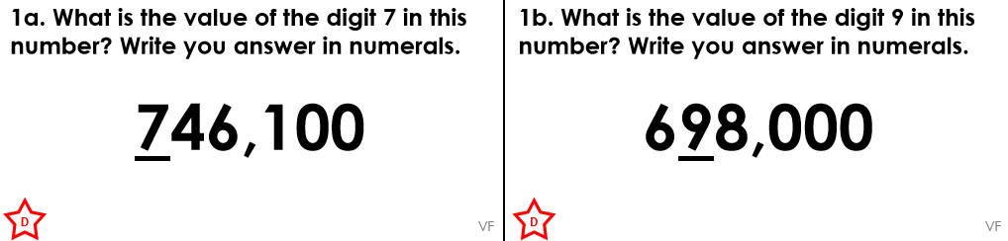

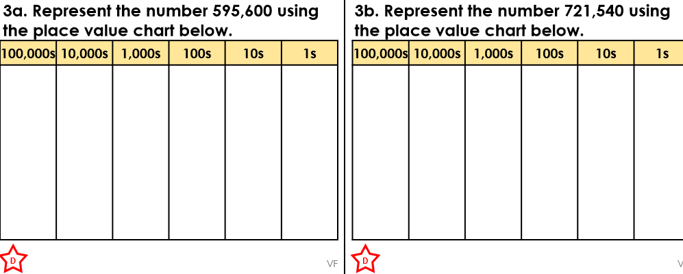

Could you ask an adult to give you some more numbers to add to your place value tables. Can you tell them the value of each digit? Could you then ROUND each number to the nearest 1,000 or 10,000?

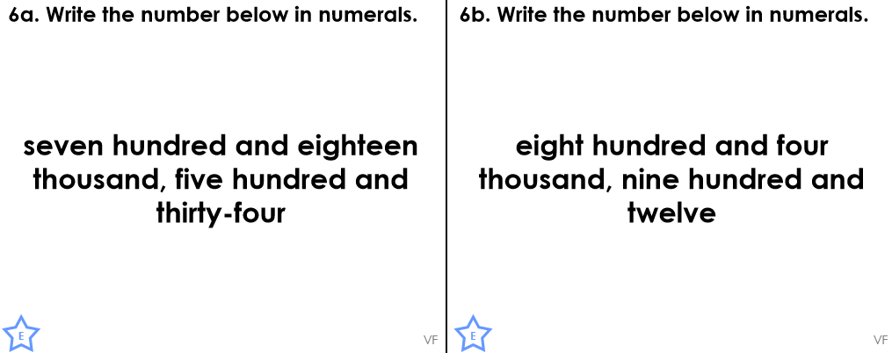

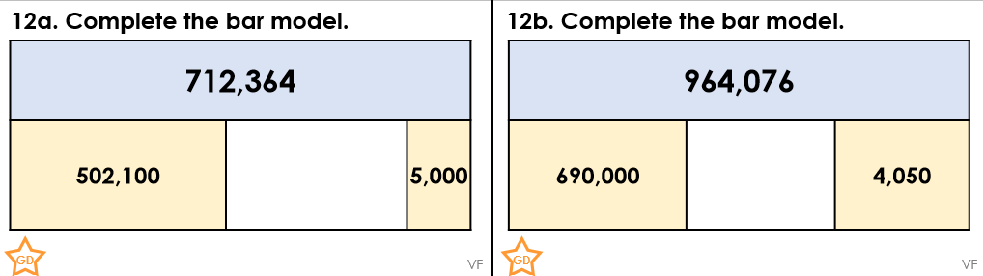

Could you create one of these ideas; ask an adult to write down a few numbers up to 1,000,000.

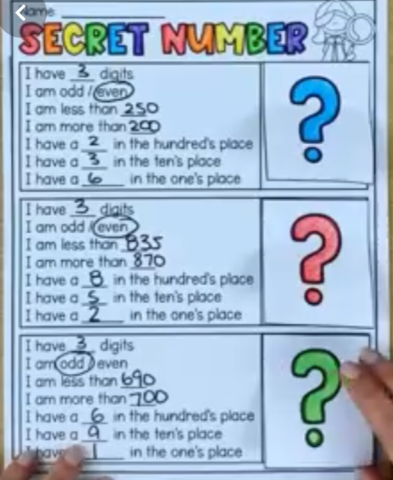 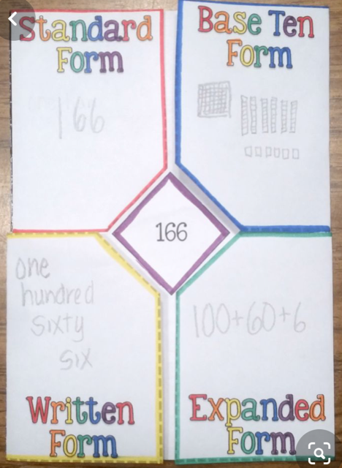

Reasoning and problem solving:

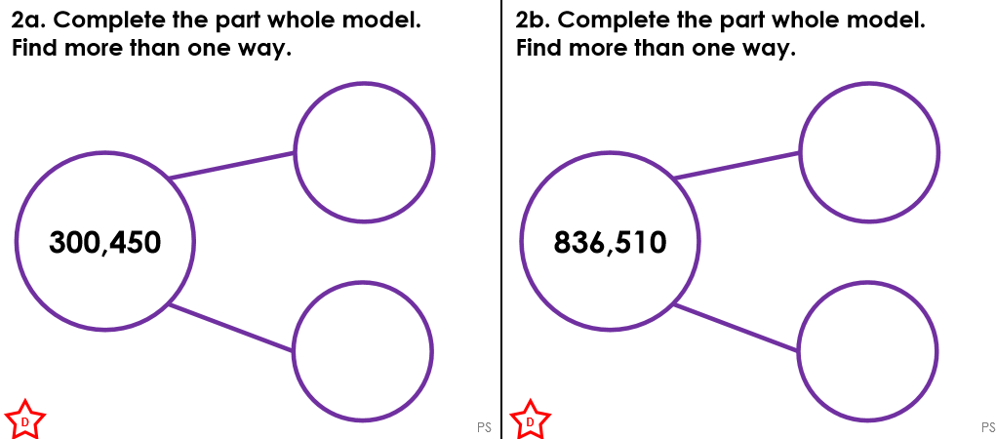

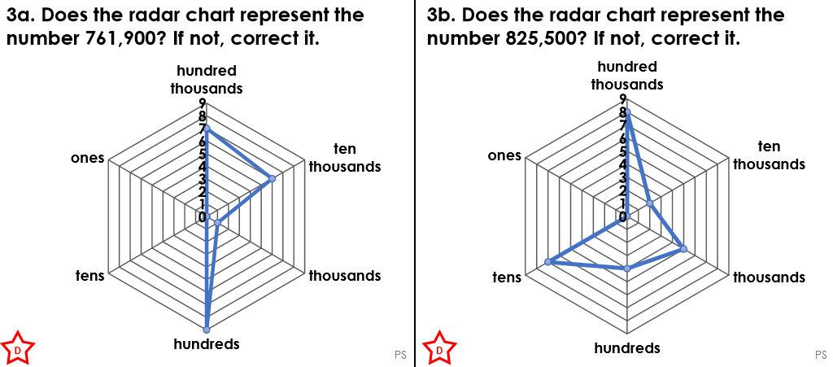

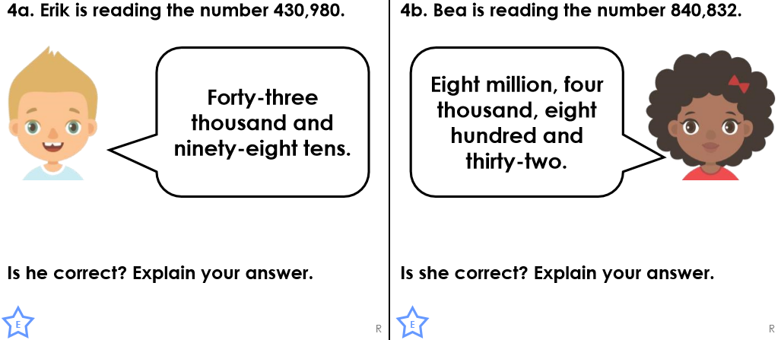 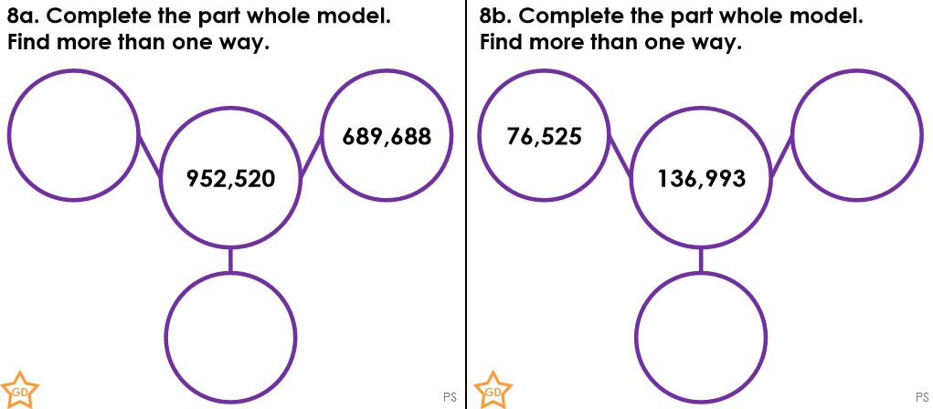

**CHALLENGE TIME!**

