Submerged City

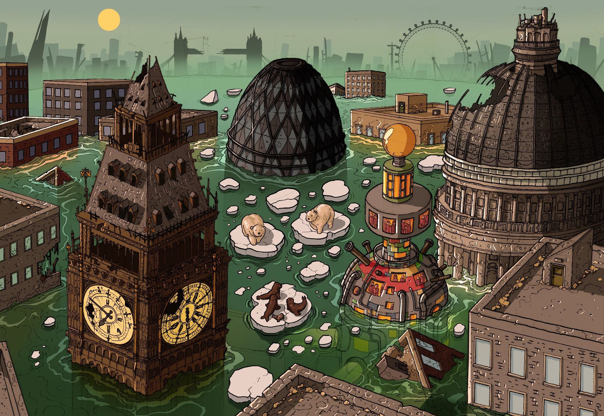

Submerged City

- Can you identify the city? What clues are there to suggest this?

- Is there anything unusual in the picture that you wouldn’t normally expect to see?

- Where would you normally expect to find the animals that are present in the image?

- What do you think has caused the flooding?

- Do you think this is a real picture of possible future events? Why/why not?

- What do you notice about the unusual tower? Why do you think it was built?

- Do you think the tower is large enough to provide sanctuary for the whole population of London? If not, what has happened to the rest of the people?

- Do you think that people would be able to live in a tower like this indefinitely?

- Would you like to live in a tower like this? Explain your answer with reference to the text.

- Do you think the rest of the UK is flooded too?

- How would you describe the body language of the polar bears and seals?

- Identify ONE question you would like to ask about this scene.

- Summarise this image in a few, well-chosen sentences.

Submerged City – Vocab 1 Write the definitions for each of these words.

apocalyptic
catastrophe
derelict
devastation
dystopia
evacuate
futuristic
indefinitely
glacier
global warming
ice cap
precipitation
sanctuary
submerged
sustainable

Submerged City – Vocab 2
Task A

Add -cial or -tial to complete these words.

- offi | - spe
- par | - artifi
- confiden | - essen

Task B

Correct the spelling of these words.
- sacrafice
- signeture
- acheive

- garantee
- appreiciate
- desparate

Challenge

Make up your own mnemonic to help you remember how to spell the following words:

Environmental

catastrophe

dilapidated

Submerged City – SPAG
- Search the image for as many different nouns as possible and record them in the chart below.

Common Noun | Proper Noun
Collective Noun | Abstract Noun

- Use a selection of the prepositions below to write sentences about the image.

above | under | next to | in front of
behind | near | between | beyond

