Place value ANSWERS:

**Fluency:**



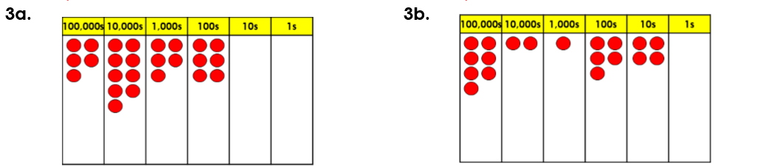





**Reasoning and problem solving:**

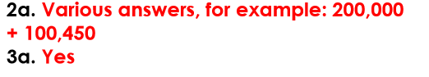 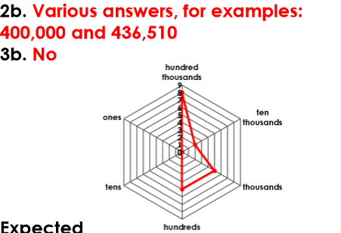

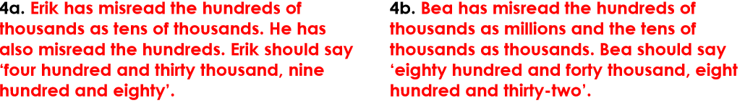



CHALLENGE TIME!

