Monday Resources
Fluency
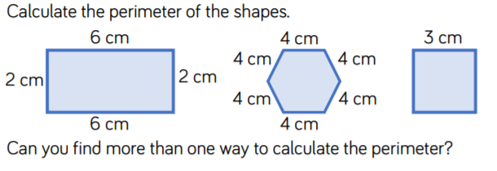
- 2. 3.

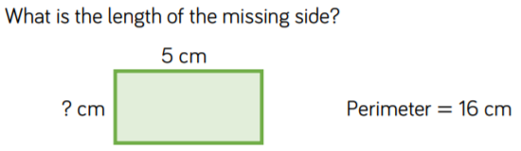
Problem-Solving
5.

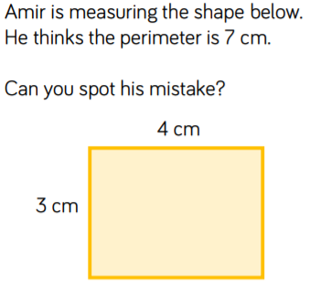
Reasoning
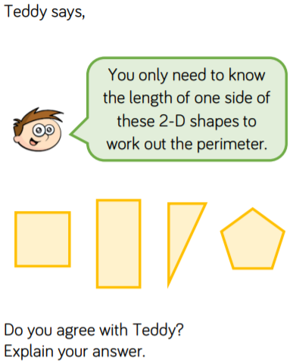
6. 7.

