Hope you are all keeping happy! Please find various activities below as well as tasks set on the year 5 class page. Email me if you need anything.
Maths:
Please follow this links below for various maths activities. There are also other activities set on the class page:
Supermovers: Practise those 8 times tables! https://www.bbc.co.uk/teach/supermovers/ks2-maths-the-8-times-table-with-filbert-fox/z4mrhbk

Nice little re-cap for some of you: https://www.youtube.com/watch?v=275NR9sNE40 Use your place value chart in your resource pack and join in!

Let’s make maths ‘real life’
Could you make a menu for a family of 4? Draw up your menu and list all the ingredients you will need. Then go onto a supermarket website to find the prices of your items…..does it fall within your budget of £10? How creative can you be? (this is just imaginary…..so don’t feel like you actually have to do/make, unless you wish to!).
Could you then design your menu….use persuasive language to convince your family that your menu is amazing!

English:
Could you include modal verbs in your writing?
Could you illustrate your letter?
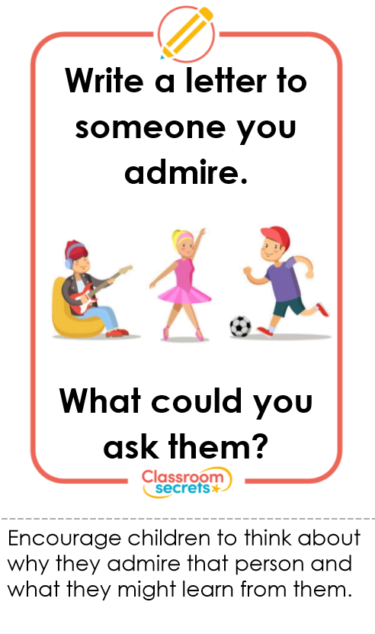

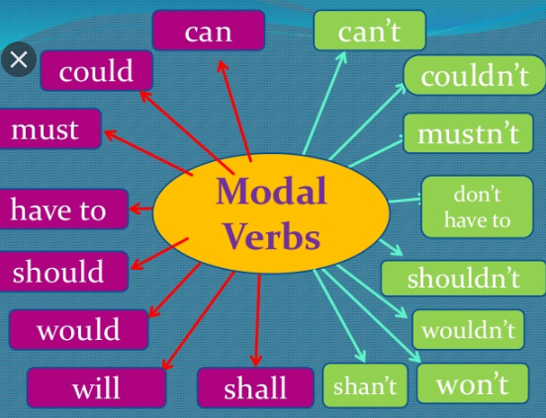

Double Page spread time!
Could you create a ‘TripAdvisor’ double page spread reviewing your home. Write a review about:
- The food…..what meals would you recommend? What’s been your favourite meal?
- The accommodation…describe the rooms in your house.
- Leisure activities…how do you relax? What do you do to keep fit?
- Outside space…how do you enjoy your outside space?

Make this as colourful as possible. What rating would you give your home?
I would love to see your work illustrated and beautifully set out.

I have set 2 grammar activities on purple mash.
Get Active!

You can follow Joe Wicks daily on YouTube….He is carrying out morning fitness sessions every morning at 9am.

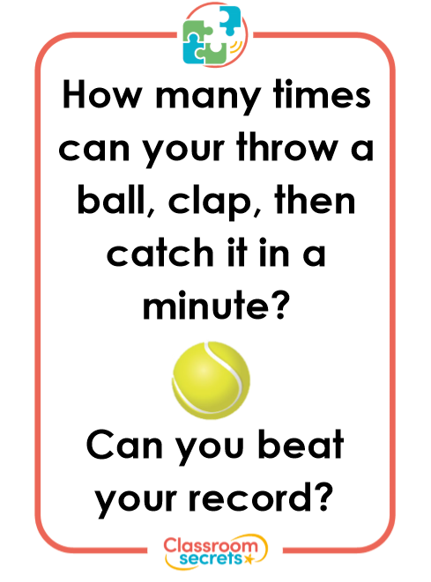

Reading:

- I have attached an ‘independent reading activities’ list. Could you pick a couple of these ideas and use them whilst reading your book. Keep a list of your responses on the paper that we have put in your resource packs.

- Keep reading daily for at least 15-20 minutes…. Could you create a den somewhere in your house to read?

- Fact or opinion? Watch the BBC bitesize video: https://www.bbc.co.uk/bitesize/topics/zs44jxs I have also set a worksheet, can you identify fact from opinion?

- I have included a comprehension activity on the class page for you to complete.

ART!
Could you make a mobile, using nature as your inspiration?
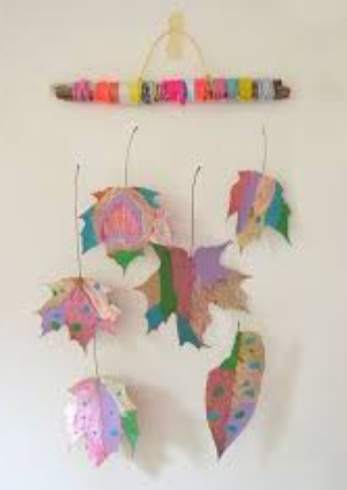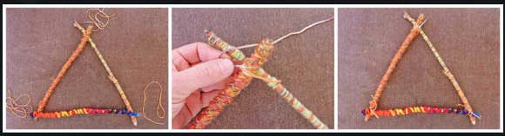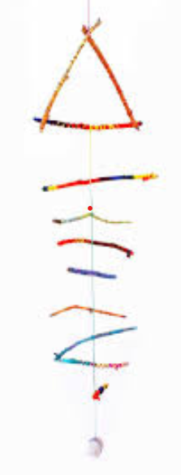
You could hang these in your windows to cheer everyone up!

Have you done everything on the ‘topic grid’ that is in your resource folder? Could you choose something from the list to complete in the afternoon.

