Ring-A-ring around o Rosies,
A pocket full of posies
A tishoo! A tishoo!
We all fall down

What was the impact of the Great Plague on London?
The Great Plague stalked England in 1665. It struck London particularly hard – by year's end, some 100,000 people had died terrible deaths.
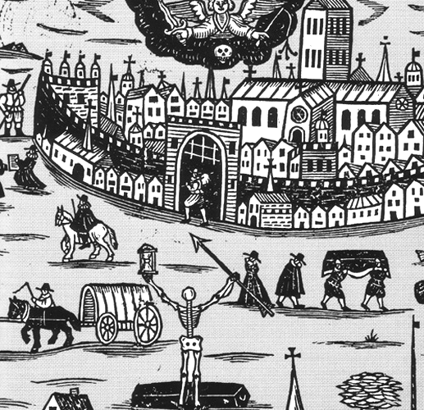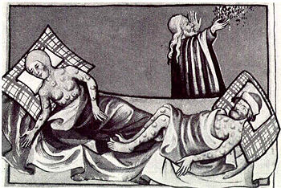
The different types of the plague
There are three human types of the disease.
Bubonic plague is the most common. A flea bite deposits the bacilli into the body. As a result, the disease is characterised by 'buboes', large, inflamed and painful swellings in the lymph glands of the groin, armpits or neck, depending on where the flea bite occurred. Historically, 60% of all those infected died of bubonic plague.
In septicaemic plague, which is almost always fatal, the bacilli enter the bloodstream directly, rather than the lymphatic system (kidney, liver, lungs) where they might be contained. Like bubonic plague it is caused directly by flea bites.
Pneumonic plague is the most deadly: it is usually fatal and it does not require flea bites to spread. When the bacilli reach the lungs, severe pneumonia occurs, and the bacilli are present in the water droplets spread by coughs and on clothing. Thus it is highly contagious, especially in crowded, poorly ventilated buildings.
Death occurs quickly with pneumonic plague – within three or four days. In all three, internal bleeding causes large bruises to appear on the skin – hence the plague's name in the 14th century, the Black Death.
The effect of the plague on London
Q: How did the plague affect London, in the larger sense?
A: London suffered a probable 20% loss in its population – 98,000 [both the dead and those who left the city]. However, we know that the population of London recovered two to four years later.
There was disruption to the economy. There were lots of bankruptcies – you can look at the exchange records. But within two to three years, London was again a thriving community. Cock and Key Alley was exactly the sort of place that was replenished by new blood, by younger people coming in.
What is amazing is that by December/January of the following year, everything is back working smoothly. And then another catastrophe hits – it all goes up in smoke ...

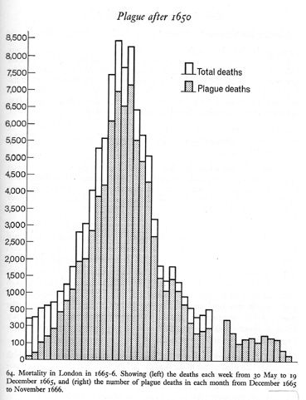
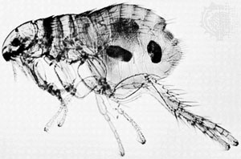
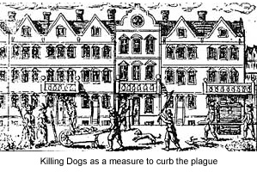
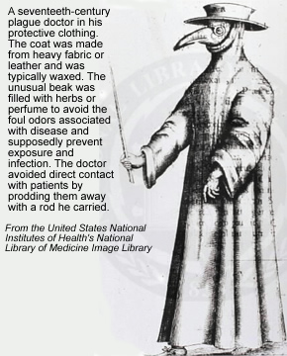

Disease was rampant in the 17th century. In England, people nervously read the Bills of Mortality, published every week, which listed the number of deaths and their causes. Plague was the most feared disease of all: people died of it every year, and the Black Death – which had killed nearly one third of Europe's population (20 million people) in the 1300s – still scared people.
The plague was terrifying because it struck swiftly. Victims died within days, in agony from fevers and infected swellings. It spread at a horrifying rate, too, and could ravage a town or even a city within weeks. With no cure, the authorities relied on drastic methods to contain it. Many european countries built large plague hospitals – 'pest houses' – to hold victims, but England preferred cheaper local solutions. Its 'plague orders' decreed that victims should be shut into their own houses and left to die.
Causes of the plague Some physicians believed poisonous air floated round, infecting all who inhaled them. Others blamed livestock for carrying the plague. Many simply thought that plague was God's punishment for sin. In fact, the plague was caused by a bacillus in the fleas that lived on black rats.
The coming of the plague The first case of what was to become the Great Plague of London was discovered in April 1665 a built-up area just to the west of the walled City. By the end of May, 11 people had been infected – enough to cause alarm. Victims were shut into their houses and the doors were nailed shut and marked with a large red cross. Nurses were hired to take in food and carry out basic care, and guards were set on watch to make sure that the sick (or their families) did not escape. People fell sick across St Giles; then cases broke out within the City walls and spread across the districts of Whitechapel, Westminster and Southwark. An exodus began. The rich left the city and most of the physicians went with them. Many clergy left too. The king and his court decamped to Salisbury. The poor, on the other hand, were forbidden to leave London.
Attempts at prevention The people tried desperately to protect themselves. They sniffed herbs and nosegays to drive out the bad air. They fasted and prayed. Apothecaries did a bgood trade in potions and religious and magical amulets. Many markets were cancelled and street stalls banned. Forty thousand dogs and 80,000 cats were slaughtered. This last move actually made things worse, as the plague- carrying rats were now free of predators. By the end of July, more than 1,000 Londoners were dying each week.
The plague disappears In the third week of September, 8,297 official plague deaths were reported. The real number was certainly higher, families hid deaths for fear of being shut in, many simply died unrecorded.
But as the weather turned colder, the rate of infection began to fall. In October, people started returning to London, and during the winter, trade gradually resumed and London's streets became busy again. The epidemic was not yet over: new cases continued to appear in London and many provincial towns were badly stricken in 1666. But London was a living city once more, if a diminished one. The Bills of Mortality list 68,576 plague victims in the capital. The true figure is probably nearer 100,000.

Activities:

- What were the three types of Plague? How were they different?
- What did people think caused the plague? Why may they have thought this?
- How did people try to prevent the plague?
- What impact did the Plague have on London? A) Business B) Personal lives
Make a copy of the diagram above with an explanation of the suit
- How and why did the Plague ‘die away’?
EXT: Explain the nursery rhyme ‘A ring-a-ring o rosies’

